DNA TERSE: Evolution and Architecture
The threaded Z80 system behind Sea Wolf II, Gorf, Robby Roto, Ms. Gorf, Demons & Dragons, and Professor Pac-Man
TERSE was the Z80 programming system developed at Dave Nutting Associates (DNA) for Astrocade-derived arcade hardware. It joined a direct-threaded execution engine to native Z80 code, a stack-oriented language, an interactive development environment, and—later—game-oriented VGS and VGER vocabularies.
Alan McNeil created TERSE while working as a programmer at DNA from March 1977 through April 1979. He designed the original Z80 direct-threaded engine and the execution contract that joined threaded control words to native Z80 routines. Sea Wolf II brought that design into a commercial arcade game in 1978. The register model, colon-entry mechanism, separate control stack, native return path, and selectively linked vocabulary established there remained the foundation of DNA’s TERSE games for the next five years.
Each shipped game contained a linked target vocabulary selected for that product. Its words could be native Z80 primitives, compiled colon definitions, or game-specific routines written to the same execution contract. The larger Forth development system remained on the host.
Across the lineage, threaded and native words share an application binary interface (ABI): the register assignments, stack rules, inline-operand formats, and return paths that allow separately compiled words to call one another correctly.
Six DNA projects trace that evolution:
- Sea Wolf II (1978, released) uses a small threaded kernel to organize a mostly native 8 KB game.
- Gorf (1981, released) carries a broad foundational dictionary and substantial compiled graphics, sound, speech, diagnostic, and game-service vocabulary.
- The Adventures of Robby Roto! (1981, released) joins a mature runtime to extensive original TERSE block source, showing how developers used the language and VGER task system.
- Ms. Gorf (1981–1983, unreleased prototype) documents the working cross-development pipeline: GORF4A pattern source, separate logic and graphics products, pattern and animation generation, loading, patching, and target execution.
- Demons & Dragons (1982, unreleased prototype) carries the mature Gorf-family runtime onto the bank-switched 16-color platform that became the basis of Professor Pac-Man.
- Professor Pac-Man (1983, released) carries the common execution ABI and dictionary lineage into banked program ROM, protected memory, diagnostics, and a large question database.
Together they show a durable software architecture: compact threaded control code above native routines, with a stable calling convention that survived major changes in game genre, hardware configuration, and program size.
This is one continuous engineering history. Sea Wolf II establishes the small kernel. Gorf and Robby Roto establish the mature language and game system. Ms. Gorf exposes how that system produced an arcade image. Demons & Dragons moves it onto banked 16-color hardware. Professor Pac-Man extends that platform into DNA’s largest surviving TERSE program.

Contents
- Space Cadet — TERSE 101
- Space Captain — Reading compiled TERSE
- Space Colonel — TERSE on Astrocade hardware
- Space General — From runtime to development system
- Space Warrior — Graphics, animation, sound, and speech
- Space Avenger — Evolution, reuse, and specialization
- Notes and source base

Space Cadet — TERSE 101
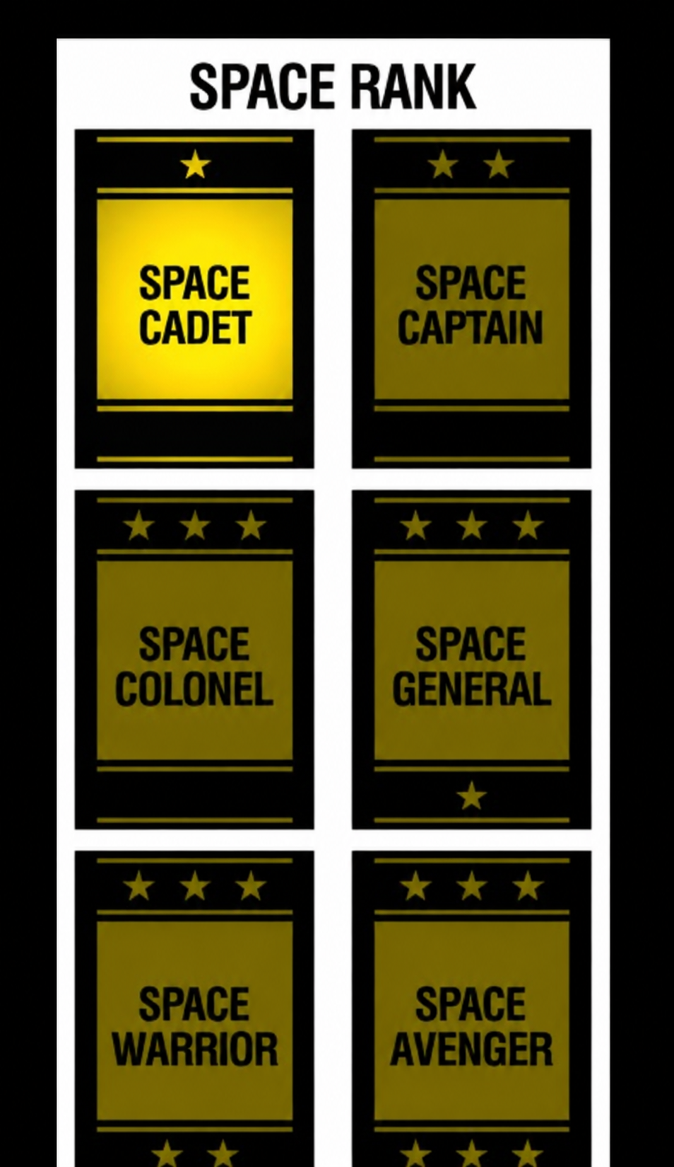
Space Cadet establishes the vocabulary needed for the rest of the paper: what TERSE was, what evidence survives, and how compiled threads appear inside a ROM image.

Origins and evidence
Alan McNeil’s résumé identifies TERSE as “a Z80 direct threaded code version of FORTH” and Sea Wolf II as written mostly in TERSE. McNeil’s tenure at DNA ran from March 1977 through April 1979, the formative period in which TERSE moved from a compact execution idea into a working arcade programming system. Former DNA engineers Tony Miller and Rickey Spiece credit McNeil with creating the engine. Their memories differ on the expansion of the name: Miller recalled Terse Efficient Reentrant Stack Engine, while Spiece recalled Terse Efficient Recursive Stack Engine. The executable code does not settle that wording, so this document uses TERSE without choosing one expansion.

Recursive and reentrant
The two recollections describe different properties. A recursive word calls itself while an earlier invocation remains active. In TERSE, each nested colon entry saves another BC return address on the IX control stack; the word’s parameters remain on the parameter stack.
A reentrant word can be active in more than one execution context without one invocation corrupting another. Reentry may come from a task, an interrupt, or another caller. Stack-local and per-task state support reentrancy; shared writable temporaries defeat it. A word may be recursive, reentrant, both, or neither. The terms are not synonyms, and the architecture supports both forms without revealing which expansion McNeil originally intended.
The history comes from several complementary forms of primary evidence:
Evidence | What it establishes
Byte-exact ROM disassemblies | Executed behavior, register roles, word implementations, inline formats, and resident vocabulary
Robby Roto TERSE block source | Developer notation, source organization, compiler forms, tasks, variables, native words, and build configuration
Ms. Gorf development disks | Host cross-compilation, object-file selection, pattern and animation generation, object merging, and target loading
ICEBOX disk, firmware, manuals, and hardware | CP/M assembly tools, internal and external execution modes, memory mapping, hardware breakpoints, target transfer, and PROM programming
Demons & Dragons ROM set | Mature TERSE ABI, Gorf-family vocabulary, banked 16-color program structure, host-dictionary residue, and an embedded Forth block-file image
1981 TERSE Standard Glossary | Canonical language names and documented semantics
VGS, VGER, assembler, editor, and debugger documents | The surrounding development system and game-service layers
Firsthand accounts and résumé material | Authorship, chronology, and contemporary descriptions
The evidence has a clear order. The glossary identifies standard words. A surviving source block records original spelling and developer notation. A game’s ROM establishes which words are resident and exactly how that program implements them. The binary ROM is source: its disassembly gives the program executed by the cabinet.
That distinction also controls naming. Primitive means a word implemented directly in Z80. Colon definition means a word compiled as a thread of execution tokens. Application word means a game-specific native routine callable from a thread. Helper means native code called by a word but not itself used as a threaded token. A descriptive reverse-engineering label is not promoted to an original TERSE name without documentary or behavioral support.

What TERSE is
At run time, TERSE is a direct-threaded machine embedded in the Z80 address space. A compiled thread is mainly a sequence of little-endian native addresses. Each address selects a primitive, application word, or colon definition. No bytecode table translates an abstract opcode into a routine; the execution token is already the routine’s address.
At development time, TERSE was much larger. The September 1981 standard glossary describes 317 verbs spanning the runtime, compiler, editor, debugger, disk tools, assembler, dictionary management, and source-block system. A game did not ship all 317. Its linked image retained the runtime subset and service vocabularies required by the application.
The resulting system has three useful properties:
- A threaded call normally occupies two bytes, reducing repeated control code.
- Native routines remain available for rendering, collision, sound, I/O, and other performance-sensitive work.
- Both forms obey one stack and register contract, so compiled control code can call optimized Z80 without a separate foreign-function interface.
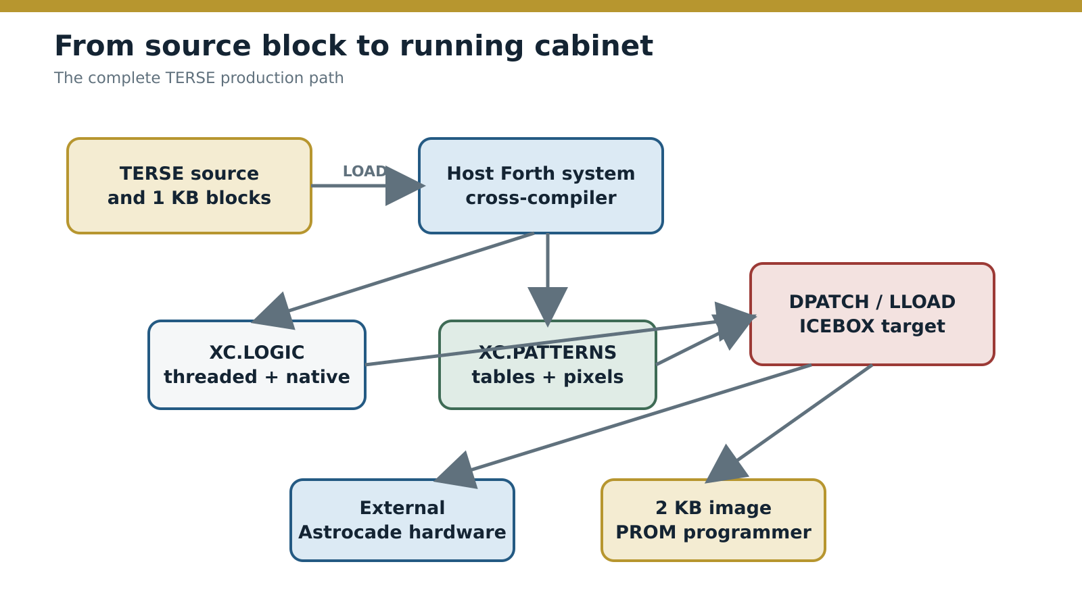
Figure — From TERSE source blocks to a running target and programmed PROM.
Source: Reconstructed from the Ms. Gorf project disks and Nutting ICEBOX archive.
The surviving Ms. Gorf material establishes separate object products, fixed graphics placement, host-image loading, and transfer into an ICE development target. The ICEBOX archive now carries the process forward with the target monitor, CP/M assembly disk, external-bus controls, split monitor ROMs, and the program that sent a selected 2 KB memory image to the physical PROM programmer.
TERSE is a hosted cross-compilation system plus a target execution architecture. Its calling convention joins threaded and native target code, while selective linking keeps the shipped vocabulary smaller than the development system.

Space Captain — Reading compiled TERSE
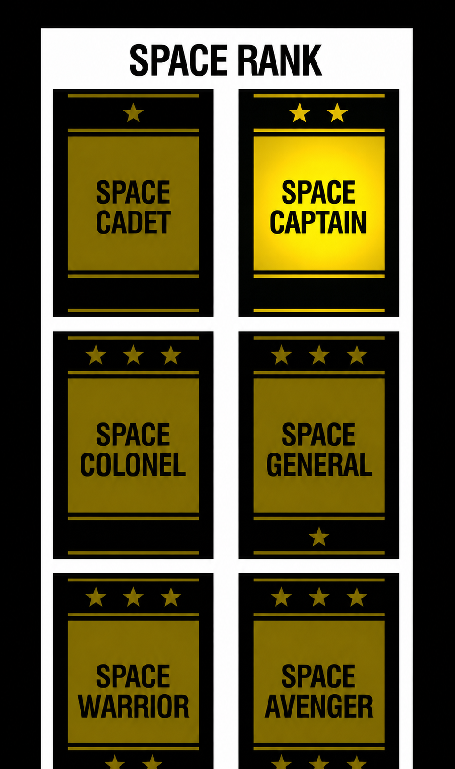
Space Captain moves from definition to execution. The goal is to read a TERSE thread, distinguish calls from inline operands, and follow original source through the cross-compiler into exact ROM bytes.

From source block to arcade ROM
The shipped game is the target product of a larger Forth environment organized around numbered 1 KB source blocks. The host system supplied the editor, dictionary, disk tools, postfix Z80 assembler, cross-compiler, and object-file controls. It compiled selected vocabularies for the arcade Z80; the cabinet did not parse source text or carry the complete development environment.
The surviving Ms. Gorf disks make this separation explicit. XCLOAD describes itself as a load block “FOR CROSS-COMPILING” and selects OBJECT-FILE XC.PATTERNS. Other screens load FILE TERSE, define target routines with CODE ... NEXT, and select XC.LOGIC for the separately managed logic product. Pattern and animation tools redirect the target dictionary pointer so generated assets land in independently allocated object regions. DPATCH declares a logic/video merge purpose. Its surviving operation injects one 1 KB table as part of the project’s object-integration workbench.
The confirmed development path was therefore:
- edit TERSE, native-code, table, and pattern definitions in Forth blocks;
- load the required host compiler and project vocabularies;
- cross-compile colon definitions into target threads;
- assemble CODE and SUBR bodies into native Z80;
- emit patterns, animation tables, and constants into target objects;
- load selected object regions into a host memory image or transfer them to the ICEBOX for execution and hardware debugging;
- send a tested 2 KB image from RAM to the PROM programmer.
The graphics-object addresses and both loading paths survive. The Ms. Gorf files begin with a completed XC.LOGIC object. The ICEBOX archive supplies the development machine and the downstream 2 KB PROM-programming stage.

Two compiler products
A colon definition becomes a sequence of execution-token addresses and inline operands. A CODE definition becomes Z80 machine code. Both become callable TERSE words because both obey the same target ABI.
Source form | Compiler output | Target execution
: NAME ... ; | Colon entry plus threaded cells | Dispatcher fetches each execution token through BC
CODE NAME ... NEXT | Native Z80 opcodes | Routine executes directly and returns through IY
SUBR NAME ... RET, | Native Z80 subroutine | Called by native or threaded service words
DATA, PATTERN, tables | Target bytes and words | Consumed by compiled or native words
This distinction explains why conventional Z80 disassembly succeeds on the kernel and then loses synchronization. It is decoding compiler output without the compiler’s type information. A word address, branch target, literal, counted string, and data-table pointer can all occupy adjacent bytes.

The compiler in FS.XC
The Ms. Gorf disks contain the surviving cross-compiler implementation. XCLOAD restores the saved system image, selects its compiler vocabularies, allocates disk buffers, and directs target output into an object file:
FSLD FS.XC
xcsys xc ASM .OPS
MORE-BUFFERS
OBJECT-FILE XC.PATTERNS
The MSGORPAT and MSGPATLD copies of FS.XC are 42 KB and 17 KB snapshots. Blocks 1 through 15 are byte-identical and contain the same working dictionary core. Its headers name xcsys, XCSTATE, OBJECT-FILE, xcverb, XCLIT, XCEND, XCDLIST, XCBEG, and XCCONT. These are compiled host words, ready to run, rather than a description of a compiler elsewhere.
The normal TERSE compiler words and the cross-compiler vocabulary work as one system. : and ; build threaded colon definitions. CODE ... NEXT builds native Z80 words. The XC* words establish the target dictionary, encode target literals and endings, calculate target addresses, and route bytes into the selected object. HELP lists the host dictionary; DLIST lists the current context vocabulary with link and code-field addresses. The next level of compiler analysis is therefore a dictionary walk through FS.XC, followed by unthreading its named host definitions.

Evidence labels used below
The examples in this paper use three labels:
- Original source reproduces surviving DNA source-block text.
- Exact ROM gives bytes read from the released game image.
- Reconstructed notation expresses decoded ROM behavior in TERSE-like source where no original source has survived.
Reconstructed notation presents decoded behavior in readable TERSE form; original source is labeled separately.

How the threaded machine works

The register contract
Sea Wolf II, Gorf, Robby Roto, Demons & Dragons, and Professor Pac-Man retain the same basic allocation of Z80 state:
Register | TERSE role
BC | Threaded instruction pointer; addresses the next execution token or inline operand
SP | 16-bit parameter stack and balanced native Z80 call stack
IX | Separate control stack for colon returns and loop frames
IY | Native continuation, normally the dispatcher
HL, DE, AF | Primitive operands, addresses, arithmetic workspace, and dispatcher scratch state
Separating the IX control stack from the SP parameter stack is central to the design. Nested definitions and loops do not occupy the same cells as game values. Native helpers may still use ordinary Z80 CALL, RET, PUSH, and POP, provided they restore SP before threaded dispatch resumes.

Direct-threaded dispatch
Gorf, Robby Roto, Demons & Dragons, and Professor Pac-Man use the same seven-instruction inner loop; Sea Wolf II performs the same operation in its compact kernel:
DSPATCH:
ld a,(bc)
inc bc
ld l,a
ld a,(bc)
inc bc
ld h,a
jp (hl)
The dispatcher reads a little-endian address, advances BC to the next cell, and jumps to the selected word. A normal native word finishes with JP (IY)— bytes FD E9—which returns directly to this fetch cycle.
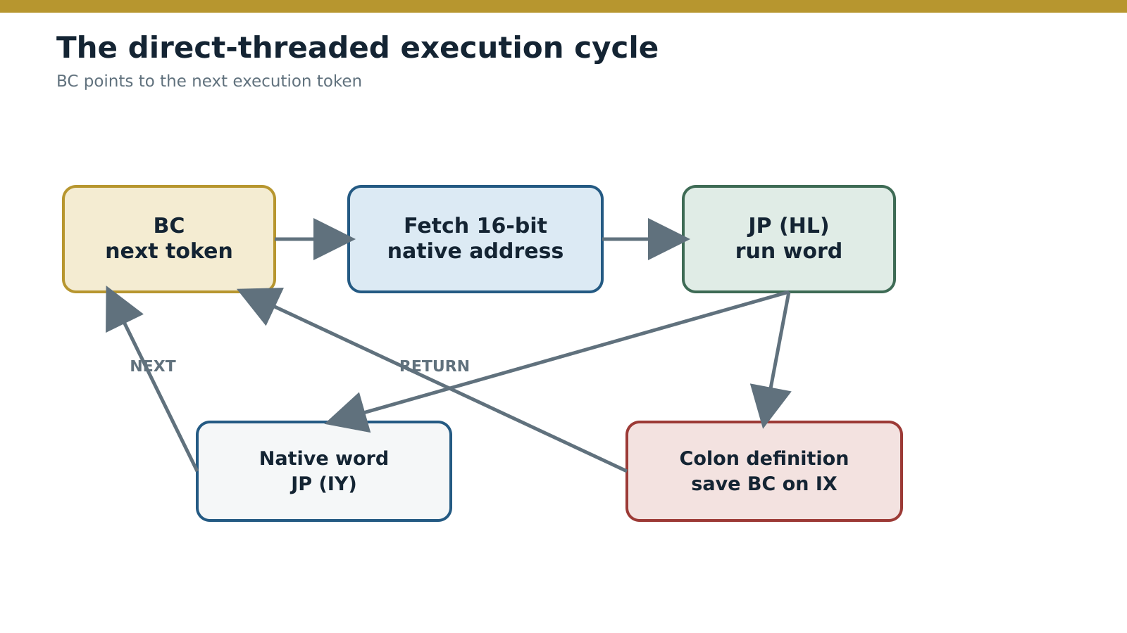
Figure — The TERSE direct-threaded dispatch and return paths.
Source: Derived from the byte-exact game ROM implementations.

Colon definitions
A compiled colon definition begins with the Z80 opcode RST $08. The RST instruction pushes the address of the inline thread on SP. The colon-entry runtime saves the caller’s BC on IX, pops the new thread address into BC, and dispatches its first token. The terminating return word restores BC from IX.
The $CF byte is therefore executable Z80 used as the colon-call mechanism. It is not the standard glossary word ENTER, which creates a dictionary entry in the development environment.

Inline operands
Not every value following an execution token is another token. Some words consume data directly through BC:
Word | Inline data | Effect
LIT | 16-bit value | Push the value
LITbyte | 8-bit value | Push the zero-extended byte
BARRAY | 16-bit base address | Add a byte index and push the effective address
ARRAY | 16-bit base address | Add a doubled word index and push the effective address
BRANCH | 16-bit thread address | Replace BC
0BRANCH | 16-bit thread address | Branch when the consumed flag is zero
A" | Counted string | Push its address and advance BC past the inline text
This is the main reason an ordinary Z80 disassembler cannot decode a TERSE application. It will interpret execution tokens, branch operands, string bytes, and ordinary data as machine instructions. Correct decoding requires the inline format and stack effect of each word.

Reconstructed example: one Gorf definition
Gorf’s XY definition scales a pair of coordinate values. No original source block is available for this example. In reconstructed notation, with hexadecimal constants made explicit, it is:
: XY $0100 * SWAP $40 * SWAP ;
The compiled body is:
XY:
db TERSE_COLON_OPCODE
dw _LIT
dw $0100
dw _star
dw _SWAP
dw _LITbyte
db $40
dw _star
dw _SWAP
dw _RETURN
The first byte enters the colon runtime. _LIT consumes the following word; _LITbyte consumes the following byte. Every other word-sized cell is an execution token. The two multiplications scale the two stack values, and the two SWAP operations retain the required result order.
This small definition displays the complete model: native Z80 entry, direct addresses, inline operands, stack-based data flow, and a return through the IX control stack.

Space Colonel — TERSE on Astrocade hardware
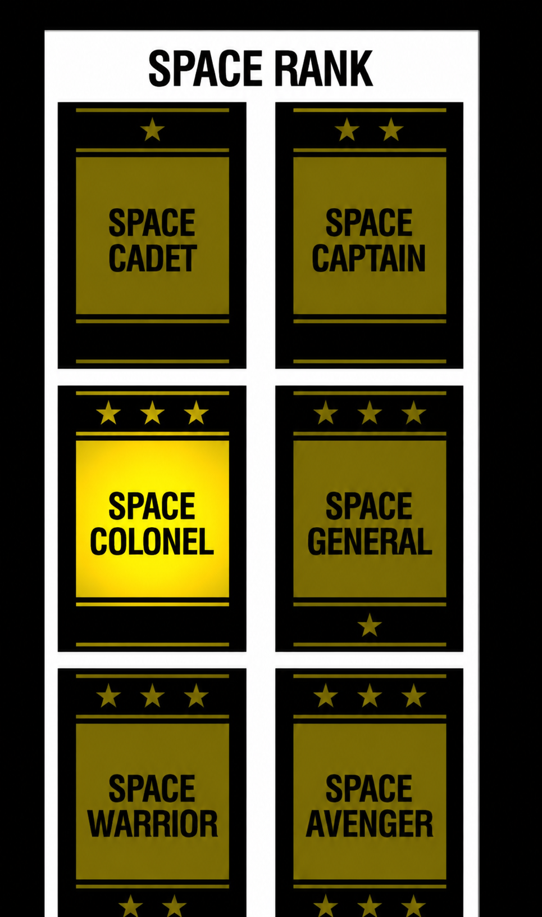
Space Colonel places the threaded machine on the actual arcade board. TERSE does not replace the hardware model: its native words expose memory, video, I/O, interrupts, and timing as operations that compiled control code can compose.

The Astrocade execution environment
The games in this study run on related Z80 boards built around the Astrocade chip set. Their exact maps differ, but they share the constraints that shaped TERSE:
Hardware feature | TERSE consequence
Z80 indirect jump through HL | A compact direct-threaded dispatcher can jump straight to a word’s native address
IX and IY index registers | TERSE can dedicate IX to control frames and IY to the native continuation while retaining BC as the threaded instruction pointer
Memory-mapped video region | Drawing words can accept compact stack parameters while native code performs address and pixel calculations
Astrocade Function Generator and Magic RAM | Shift, rotate, expand, logical-combine, and collision operations remain efficient native services
Port-mapped sound and controls | General INP and OUTP words coexist with game-specific input, sound, and speech services
Interrupt-driven frame work | Foreground threads express sequencing while native interrupt paths maintain video, sound, timers, and scheduled objects
Small ROM budgets | Two-byte execution tokens and selectively linked vocabularies reduce repeated control code
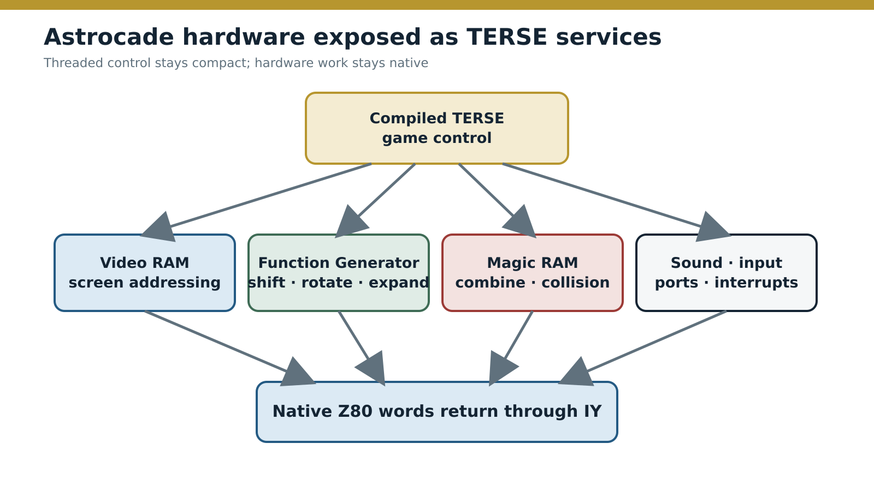
Figure — TERSE exposes Astrocade hardware through native service words.
Source: Derived from the game ROMs and Astrocade hardware documentation.
The architecture is thin. A compiled word can decide when to draw, wait, branch, speak, or start a sound; the called native word still knows the board’s ports, memory layout, and timing rules. TERSE creates a stable composition boundary without pretending the hardware is generic.

Sea Wolf II: the compact engine
Sea Wolf II is the earliest commercial TERSE implementation in this study. McNeil’s résumé dates his DNA work to 1977–1979 and identifies both the game and TERSE among his major projects. The complete program fits in 8 KB.
The ROM contains:
- 11 thread-dispatchable kernel words;
- 21 native application words;
- six complete threaded programs: an initial thread, a nested initialization thread, a control thread, and three localized GAME OVER threads.
The kernel is small by design. It provides nested-thread return, byte fetch and store, loop control, literals, byte complement, and conditional and unconditional branches. Rendering, target updates, collision handling, scoring, device I/O, and most diagnostics remain native.
This is a complete game-sized linked vocabulary. Sea Wolf II retained the control machinery and application words needed by one 8 KB product.

The foreground loop as compiled TERSE
The decoded control thread begins with a TERSE loop frame, tests game state, dispatches native application words, and converges on one loop tail:
CONTROL_THREAD:
control_wait:
dw TERSE_BEGIN
dw TERSE_INLINE_BFETCH, PATROL_COMPLETE_FLAG
dw TERSE_ZERO_BRANCH, control_no_state
dw CHECK_PATROL_END_OR_EXTENDED_PLAY
control_no_state:
dw TERSE_INLINE_BFETCH, ACTIVE_PLAYER_COUNT
dw TERSE_ZERO_BRANCH, control_no_player
dw ERASE_EXPIRED_HIT_SCORES
dw PROCESS_SHIP_HIT
dw REFRESH_DIRTY_PLAYER_SCORES
dw UPDATE_SONAR_SEQUENCE
; Additional active-patrol tests and services follow.
control_no_player:
dw INITIALIZE_OBJECT_POOLS
dw UPDATE_NEW_HIGH_SCORE_MESSAGE
; Credit arrival sets the patrol-complete byte.
control_continue:
dw PULSE_COIN_COUNTER
dw TERSE_INLINE_BFETCH, CONTROL_LOOP_EXIT_FLAG
dw TERSE_END
dw TERSE_RETURN
This excerpt is actual compiled structure expressed with descriptive symbols. The pairs after TERSE_INLINE_BFETCH and the branch words are inline operands, not calls.
TERSE_END consumes the loop flag and repeats while it is zero. That name matches the later standard glossary. The resident $FFFF constant is labeled descriptively as TERSE_CONST_FFFF; it is not called TRUE, because later TERSE documentation specifies Boolean results as zero or one and the sole Sea Wolf II caller uses the value as a stored $FF state byte. This distinction is important: architectural continuity does not justify assigning later source names where the early ROM does not prove them.

The division of labor
Sea Wolf II’s control thread does not calculate collision geometry or draw a ship pixel by pixel. It decides when those actions occur. Native words do the expensive or hardware-specific work; the thread expresses the control shape.
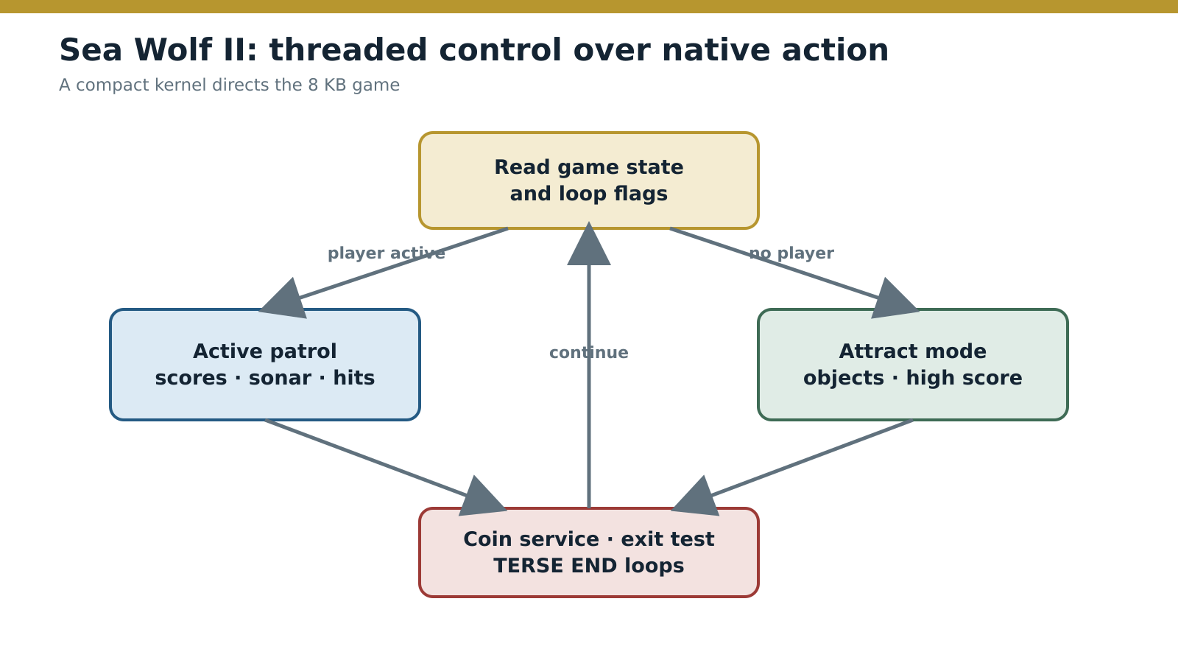
Figure — Sea Wolf II uses a compact TERSE foreground loop to coordinate native game services.
Source: Derived from the Sea Wolf II ROM disassembly.
The proven maximum parameter-stack depth is only two 16-bit cells. The deepest IX state is three cells: two nested-thread returns plus the live loop frame. Those figures fit the program’s character. TERSE supplies structured control and compact calls without forcing the game into deep stack algebra.
Sea Wolf II establishes McNeil’s original engineering proposition:
- two-byte tokens compress sequencing;
- native application words retain direct hardware performance;
- IX supports nested threads and loops independently of game values;
- one dispatcher unifies the two forms;
- unused vocabulary consumes no ROM.

Space General — From runtime to development system
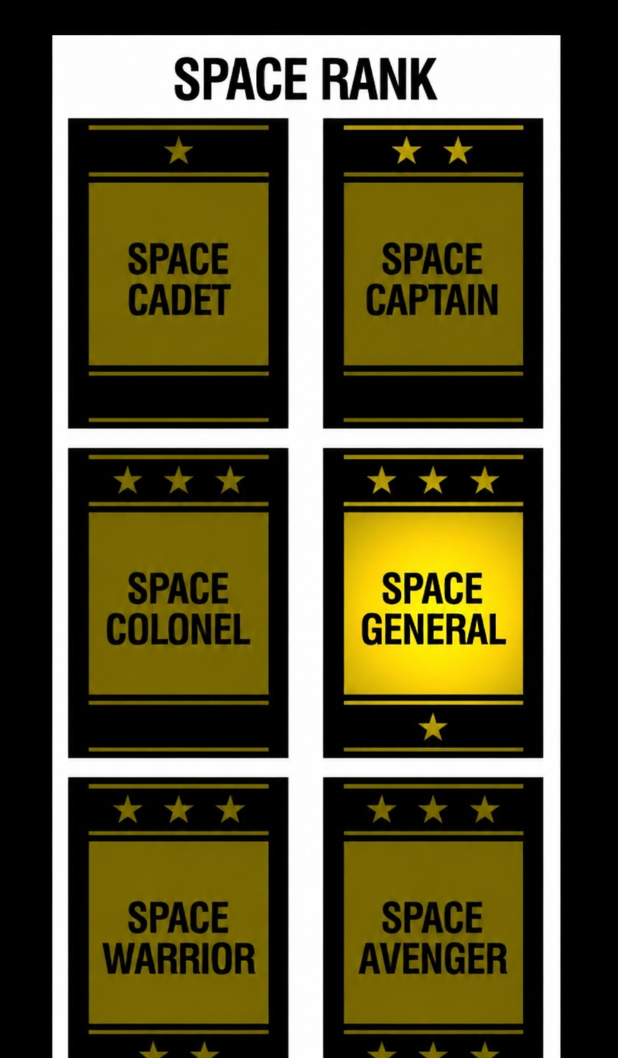
Space General widens the view from one shipped runtime to the system used to build games. By 1981, TERSE supported interactive source blocks, target assembly, cross-compilation, debugging, reusable service vocabularies, and project-specific object generation.

The complete toolchain
Between Sea Wolf II and the 1981 games, TERSE grew into a working development environment and gained game-oriented vocabularies above the core runtime.

Language and tools
The standard documents describe an interactive system organized around named words and numbered 1 KB source blocks. A block contains sixteen 64-character lines. : begins a colon definition; CODE begins a native definition; NEXT returns that native word to threaded dispatch. VARIABLE, CONSTANT, TABLE, VOCABULARY, LOAD, and BLOCK organize program state and source.
The debugger works at TERSE-word granularity. It can step the inner interpreter, show the parameter and control stacks, set execution-token breakpoints, identify a word from its code address, and uncompile a definition. The Z80 assembler is itself exposed as a postfix vocabulary, allowing a source file to move between colon definitions and native code without leaving the TERSE environment.

VGS and VGER
The Video Game System Glossary exposes drawing, coordinate, text, number, color, timing, and hardware services as words. Representative operations include VECTOR, POST, #POST, DRAW, BOX, ELLIPSE, SCROLL, SHAPE, COLOR, FLOOD, RANDOM, and SUM. Their native bodies handle screen addresses, Magic RAM modes, expansion, intercept state, and hardware ports; their callers see stack interfaces.
VGER builds scheduled game behavior above TERSE and VGS. Surviving Robby Roto source uses ;TASK: definitions, timers, WAIT, vector records, animation services, and scheduler transitions. The layers share one execution ABI: a task can call a core primitive, a VGS drawing word, a VGER service, or a game-specific native word.
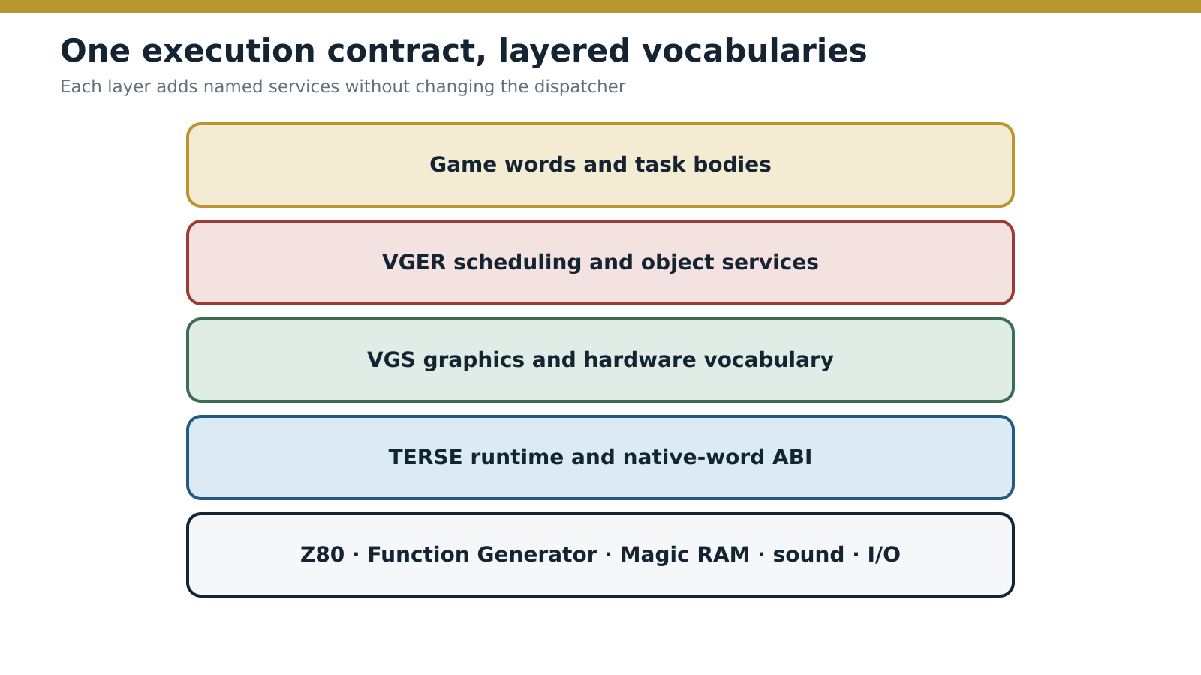
Figure — The mature DNA software stack shares one target execution contract.
Source: Reconstructed from the TERSE, VGS, VGER, and game source material.
Jamie (Jay) Fenton’s March 1979 Addin listing already identifies TERSE macros and uses TERSE CIRCLE, SHOW, and BOX commands. It captures the transition: reusable graphics vocabulary was growing around the small engine before the mature Gorf and Robby Roto systems appeared.

ICEBOX: the development machine
The ICEBOX archive supplies the physical machine behind the development loop. It contains the CP/M disk, monitor source and binaries, operator manuals, memory-map controls, board photographs, schematics, and the PROM-programmer source. Read beside the Ms. Gorf loaders, these files turn “ICE target” from a generic destination into a documented workstation.
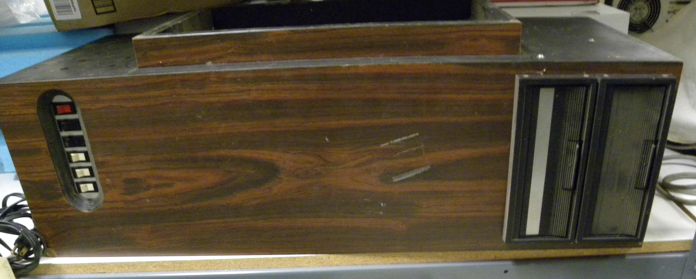
Figure — The Nutting Associates ICEBOX workstation.
Source: Bitsavers Nutting Associates archive.
The ICEBOX has two execution contexts. In internal mode, its own 2.5 MHz Z80 runs CP/M for editing and assembly. In external mode, it takes the clock and bus from an attached Arcade, Commercial Arcade, Arcade Add-On, or Pinball system. The connection uses either the 50-pin DNA bus or a ribbon cable placed in the target’s 40-pin Z80 socket. The developer can therefore prepare software on the internal machine, switch to the external target, and inspect the same address and I/O space in which the game runs.
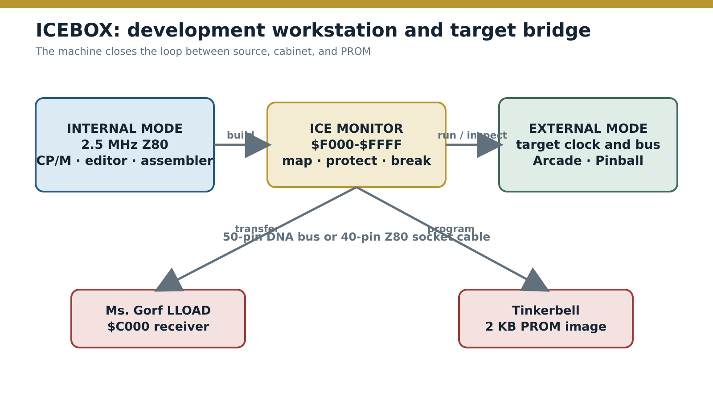
Figure — ICEBOX joins CP/M development, external target execution, and PROM production.
Source: Reconstructed from the ICEBOX manuals, firmware, and Ms. Gorf loaders.
The CP/M disk contains the TDL Z80 assembler and loader, Digital Research development utilities, local disk tools, the ICE monitor source, and Astrocade libraries:
ICE disk component | Development role
ASM.CPM | TDL Z80 CP/M Disk Assembler v2.21
ASM8080.CPM | Digital Research 8080 assembler v1.4
LOADER.CPM | TDL/SSS CP/M Loader v2.0
DDT, ED, LOAD, PIP, STAT, SUBMIT, SYSGEN | CP/M debugging, editing, loading, file, and system tools
HVG.LIB, HVGLIB.ASM | Astrocade executive, object, video, sound, and input definitions
MACRO.LIB | Bally Arcade and HVGSYS assembler macros, dated May 3, 1978
MUSIC.LIB | Musical note-frequency constants
ICE.ASM, ICEMESS.ASM | Z80 ICEBOX monitor and message source
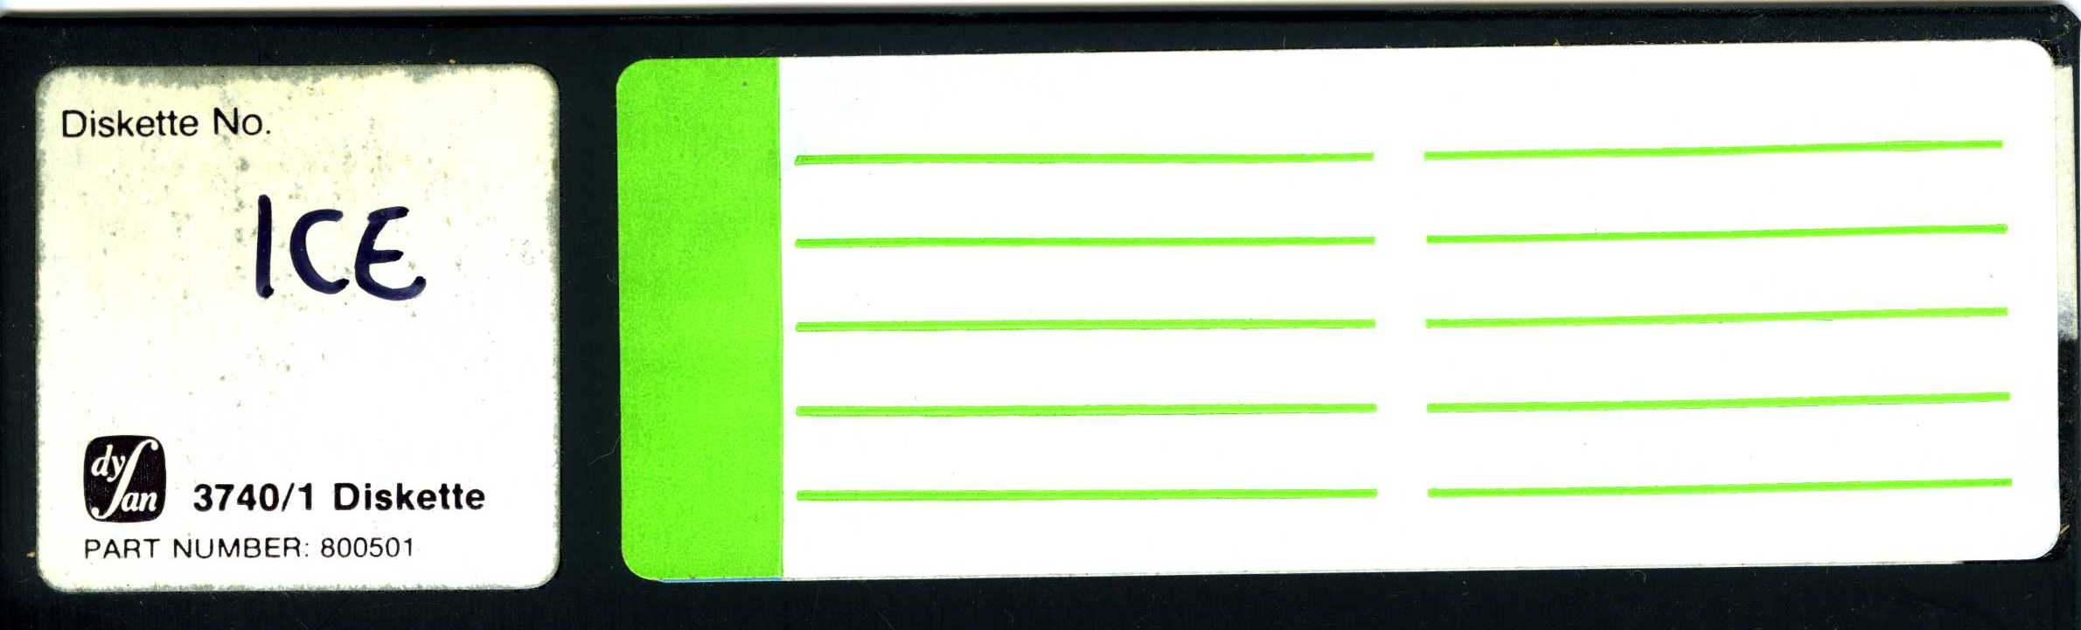
Figure — The ICE development disk contains the CP/M tools, monitor source, and Astrocade libraries.
Source: Bitsavers Nutting Associates archive.
ICE.ASM identifies the monitor as Z80 IceBox version 1.0; its sign-on text is Al's ICEBOX Version 1.0. The archived PROM dump is 4 KB. In the operating address map, monitor ROM occupies $F000-$FBFF and ICE scratch RAM occupies $FC00-$FFFF. The monitor controls the mapping and breakpoint hardware through ports $F8-$FF. Arcade mode exposes external memory at $0000-$1FFF and $4000-$4FFF. Commercial mode exposes $4000-$7FFF, $C000-$CFFF, and $E000-$EFFF. Debug mode supplies memory and port read/write breaks, go, single-step, hexadecimal and ASCII dumps, register editing, and memory and port modification.

Control-T and the TERSE bootstrap
The supplied ICE.ASM is the earlier CP/M-oriented monitor source and handles Control-C as its disk boot. The dumped monitor ROM adds a separate Control-T path. That routine homes the drive, selects sector 1, reads thirty-two 128-byte sectors directly into $0000-$0FFF, and jumps to $0000. In TERSE’s one-kilobyte source-block terms, Control-T loads blocks 1 through 4: the four-kilobyte bootstrap that brings the hosted language to life.
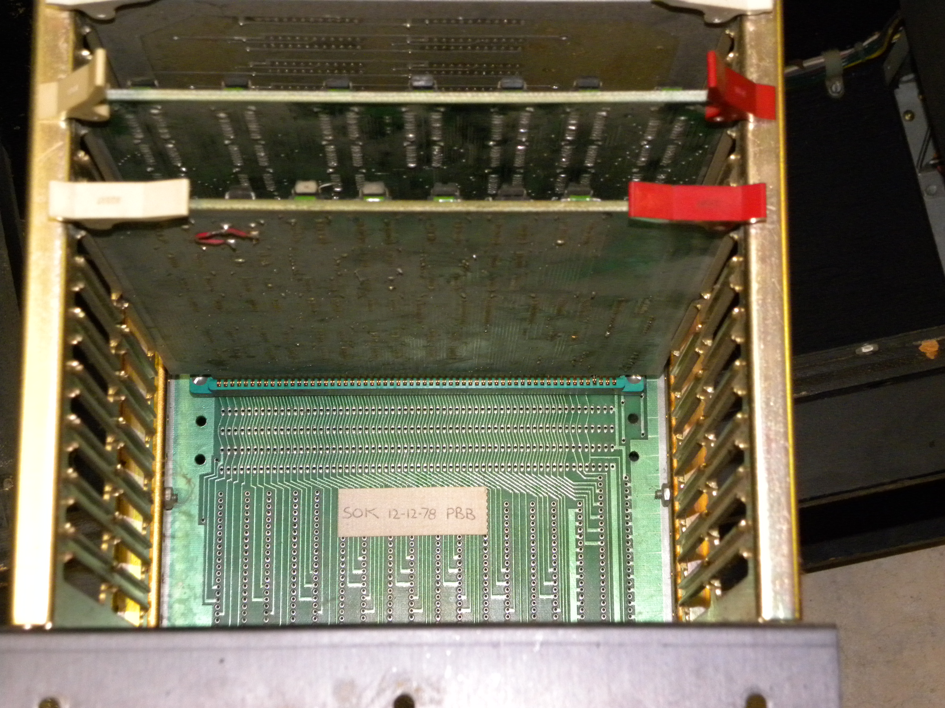
Figure — ICEBOX chassis and board cage.
Source: Bitsavers Nutting Associates archive.
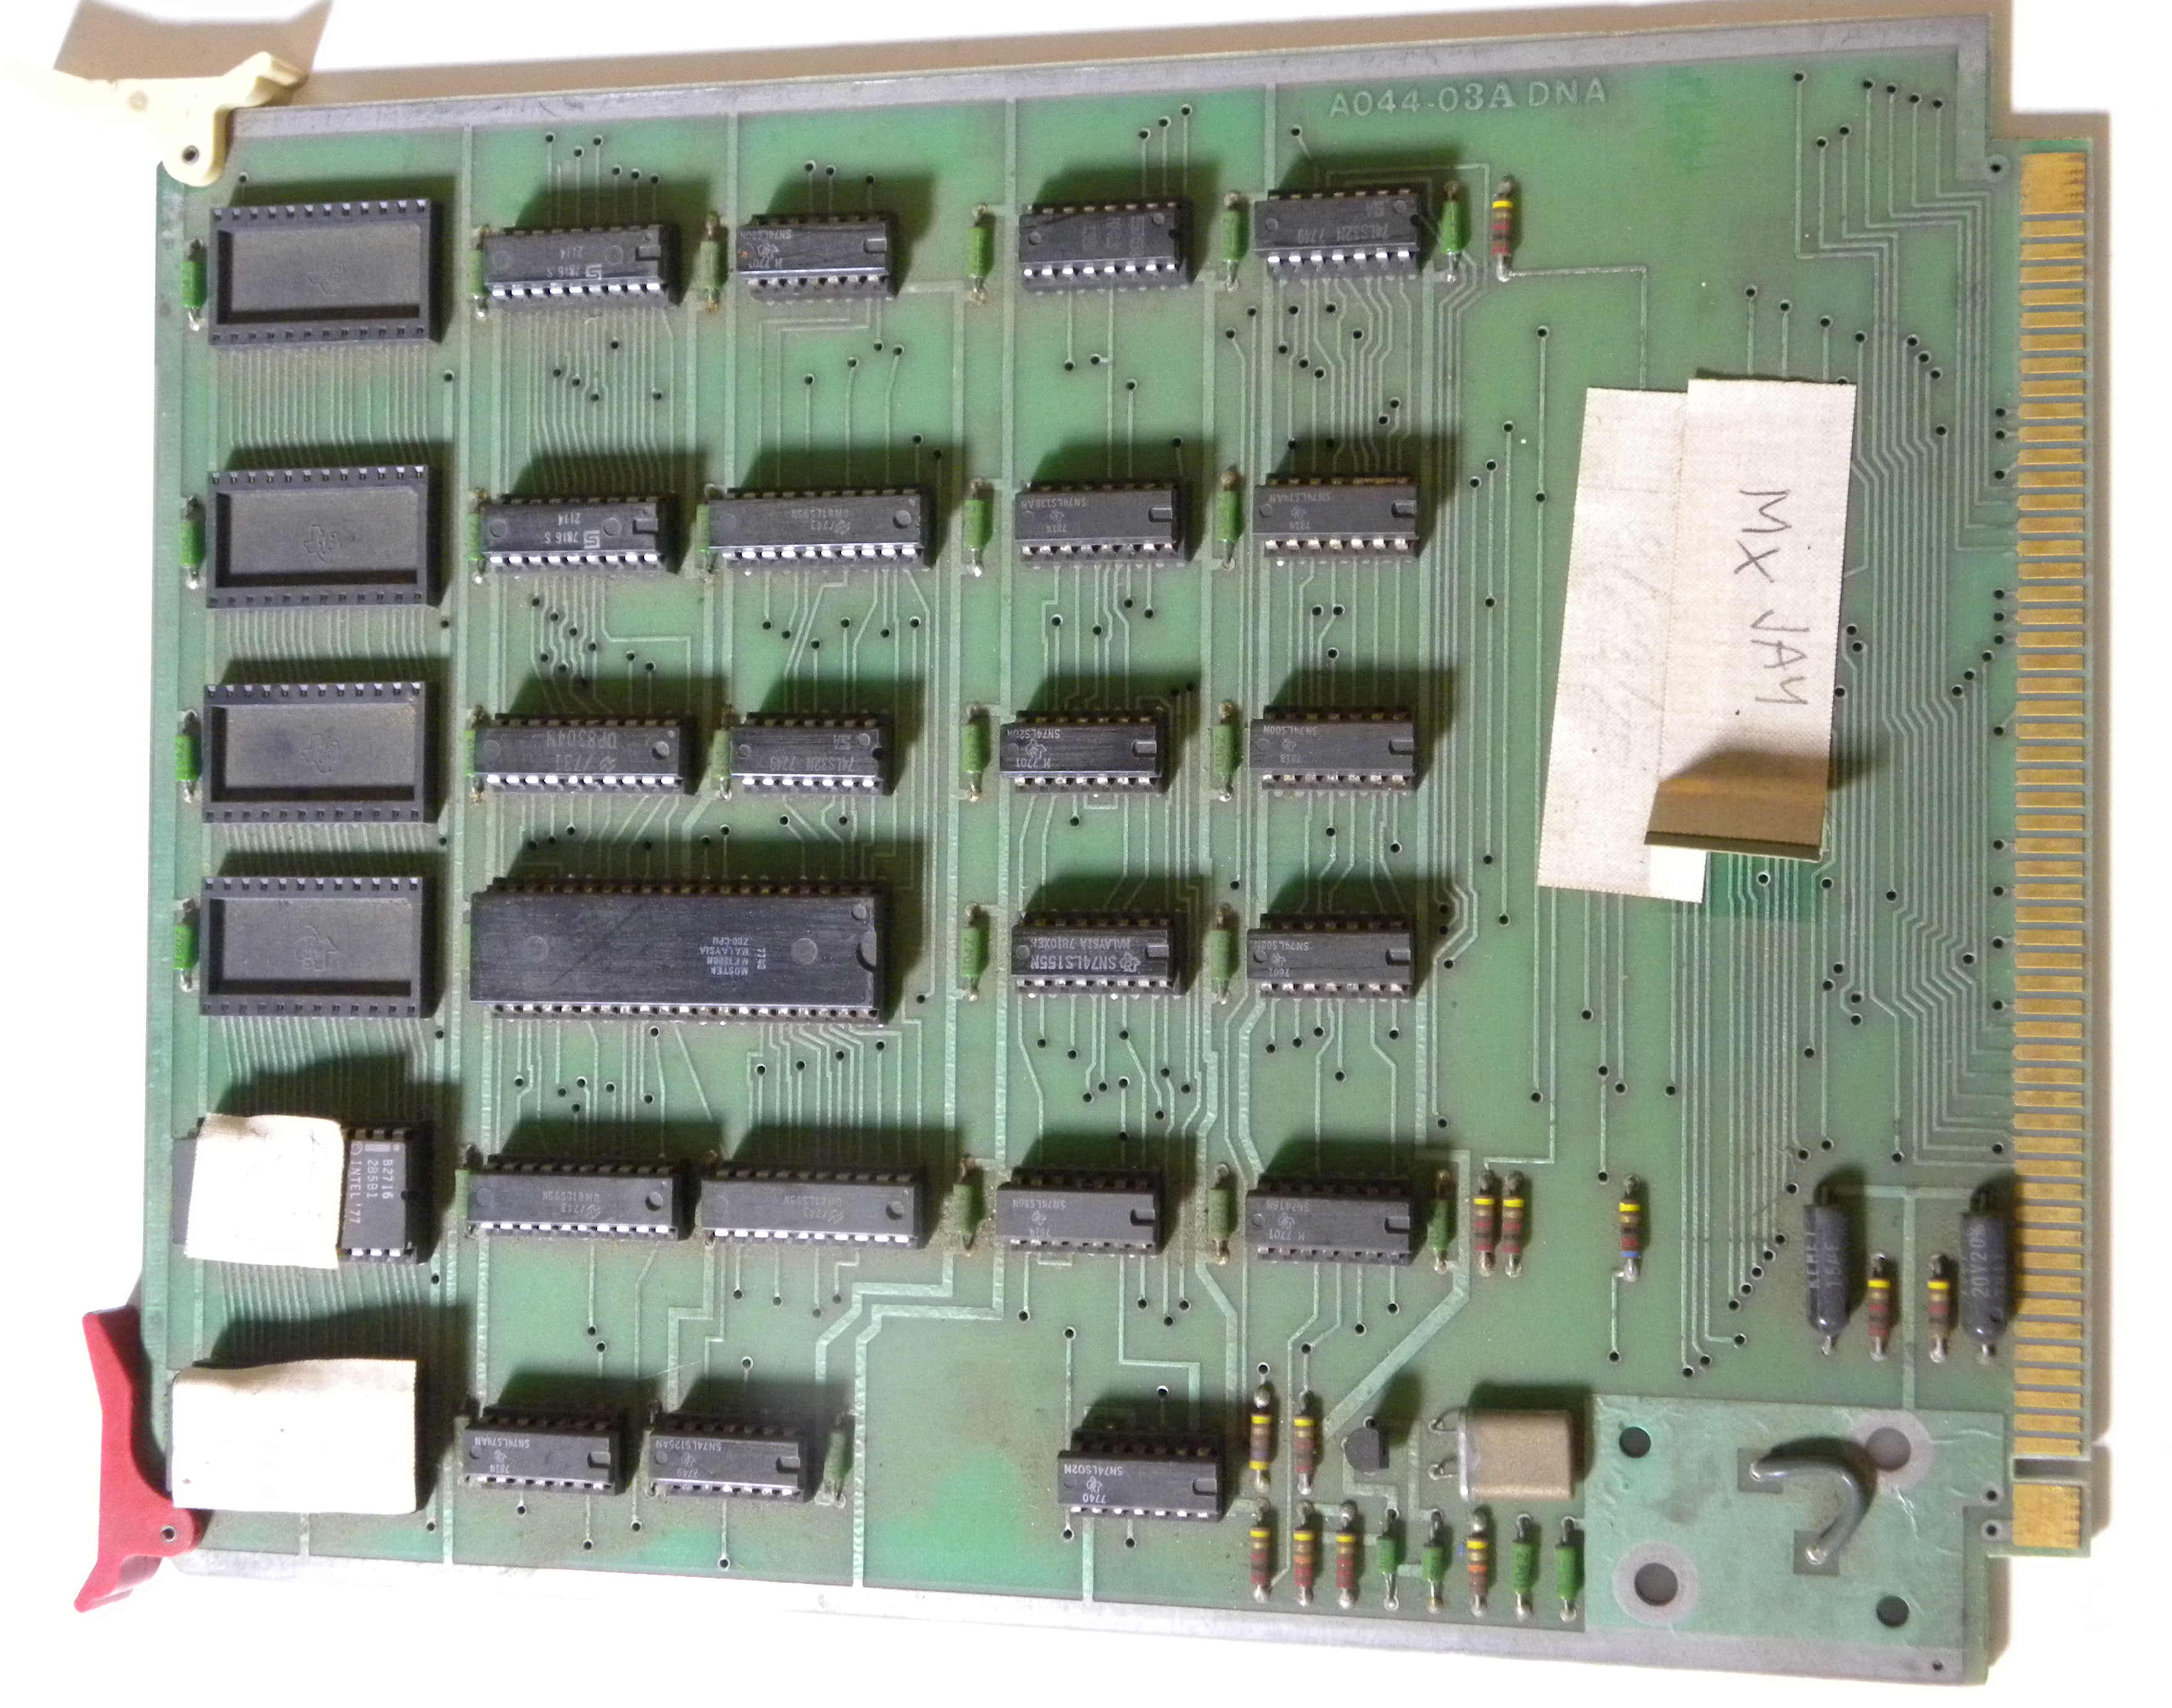
Figure — ICEBOX CPU and control board.
Source: Bitsavers Nutting Associates archive.

Figure — ICEBOX CPU-board schematic.
Source: Bitsavers Nutting Associates archive.
The archive contains the firmware in three byte-exact products:
ice0.bin (2 KB) + ice1.bin (2 KB) = ice.bin (4 KB)
Four monitor-source files on the CP/M disk are identical to the copies retained with the firmware. PROM.ASM, labeled Tinkerbell Prom Programmer Program, accepts a RAM address and sends exactly 2,048 bytes to the programmer. This is the production boundary at the far end of the TERSE toolchain: a tested memory image becomes a physical PROM.

ICEBOX in MAME
MAME’s ICEBOX driver is a working model of the machine’s internal core and a precise record of the remaining emulation boundary. It starts the Z80 at $F000 and implements the two 8251 serial channels, baud-rate generator, FD1771 controller, two eight-inch drives, serial terminal, and drive selection at port $F1. The implemented I/O map covers $E0-$E7 and $F1.
The external target bus is not emulated. The driver does not yet implement the control register at $F0, the three-byte FIFO at $F2, or the external-map, write-protect, and breakpoint registers at $F8-$FF. Arcade and Commercial modes can issue their hardware commands, but MAME cannot yet connect those commands to an Astrocade target or reproduce ICEBOX hardware breakpoints.
The driver reaches the % monitor prompt and accepts its commands. Its CP/M boot reads track 0, begins the eighteen requested sectors on track 1, and stops after eight. The source identifies the unresolved FD1771 transaction as the current failure point. A disk is mounted explicitly:
mame icebox -flop1 /path/to/disk.imd
MAME’s -skip_gameinfo option only suppresses the system-information screen; it is not required to run the driver. The skeleton status means the model is incomplete, not that the ROM, disk, or documented monitor behavior is speculative.
The GAS monitor documentation connects this workstation directly to the language environment. Version 2.33, dated September 21, 1981, offers Arcade, CP/M, and GAS TERSE boot commands alongside disassembly, breakpoints, memory display and modification, fill, go, and register operations. TERSE supplied the source and target vocabulary; the ICEBOX supplied the machine control needed to run that target code against real Astrocade hardware.

Ms. Gorf: the production system made visible
Ms. Gorf belongs in the TERSE lineage because its disks document the machinery that turned the language into a game. The ROMs show what TERSE executed; the Ms. Gorf project shows how DNA built, placed, loaded, and tested it.
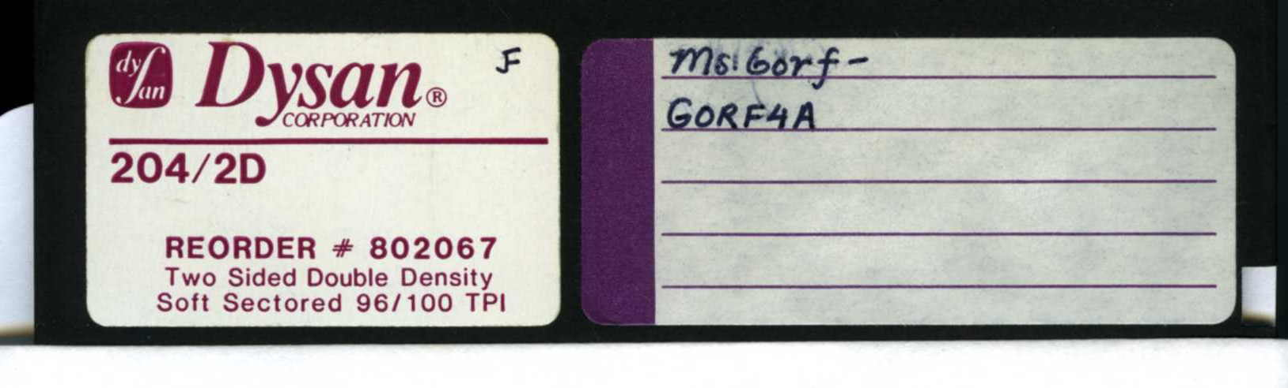
Figure — The GORF4A graphics source disk.
Source: Ms. Gorf development-disk archive.
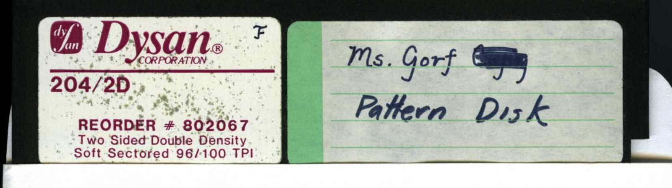
Figure — The MSGORPAT pattern-production disk.
Source: Ms. Gorf development-disk archive.
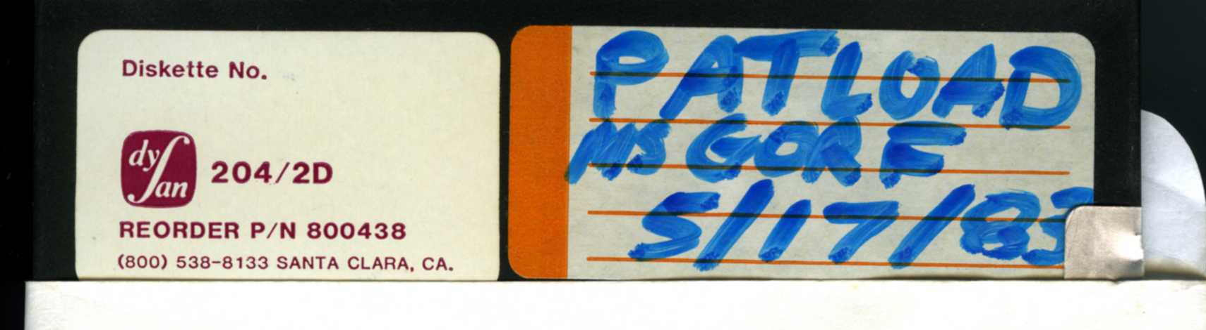
Figure — The MSGPATLD loader and pattern disk.
Source: Ms. Gorf development-disk archive.
The later pattern disk is labeled May 17, 1983. Jay Fenton signed its team instructions the next day. Those instructions assign the stable game-facing INDEX to Jay and the asset-facing ANIM-MAP to Kasey and Jan. The files therefore capture both the toolchain and the working boundary between game logic and graphics production.
The project maintained XC.LOGIC and XC.PATTERNS as separate target objects. The pattern build emitted a stable index at $4000, animation tables at $4200, and bitmap data at $8000 or $8040. Logic referred to graphics through the stable index rather than depending on the current physical address of each asset. DPATCH supplied the block-level table injection at that boundary, while BINLOAD and LLOAD supplied two execution paths: load a host memory image or transfer the cross-compiled image into the ICEBOX.
This establishes the normal DNA development loop:
- edit TERSE source and asset blocks;
- cross-compile threaded definitions and native Z80 words;
- generate separately placed graphics and animation data;
- combine the target objects;
- start the ICEBOX receiver at $C000;
- transfer the image through the shared 1 KB staging window;
- execute and debug it on the external Astrocade target;
- send the finished 2 KB memory image to the PROM programmer.
LLOAD makes the handoff explicit. The host writes a destination address at $C005-$C006, copies one block into $C400-$C7FF, raises the flag at $C004, and waits for the ICEBOX receiver to clear it. Eighteen blocks fill $0000-$47FF. The receiver then programs the ICE control ports and jumps to the game at zero.
The disk decoder reproduces all 31 files in MSGORPAT and all 33 in MSGPATLD byte-for-byte. The third disk adds the exact 13 KB GORF4A source file: nine populated quaternary-pattern screens and four blank continuation screens. XC.LOGIC remains named in the loaders and in an older FS.XC directory record; its former block-110 allocation is occupied by XC.PATTERNS on the pattern disks. The logic bytes remain the one missing project object between the surviving build screens and a complete Ms. Gorf ROM image.

Gorf: the mature arcade runtime
By Gorf, TERSE had become the foundation of a reusable arcade software system. The eight program ROMs contain a decoded foundational native field of 82 words, followed by compiled definitions and extensive game-service vocabulary. The foundational field covers:
Category | Representative words
Thread control | LIT, LITbyte, BRANCH, 0BRANCH, LEAVE
Stack operations | DUP, 2DUP, DROP, SWAP, OVER, ROT, PICK, 2DROP
Memory | @, B@, !, B!, ZERO, BMOVE, +!, 1+!, 1-!
Arithmetic and logic | +, -, MINUS, *, /MOD, AND, OR, XOR, NOT
Comparison | Equality, signed and unsigned relations, zero tests
Loops | DO, LOOP, +LOOP, I, J, K
Hardware and data | INP, OUTP, ARRAY, BARRAY, A"
The count covers the foundational native field. Gorf adds compiled utility words and game-specific graphics, task, animation, input, audit, sound, speech, and mission vocabularies.

Source-derived example: a diagnostic word
The source-derived transcription for CKCHIP describes a ROM-check display operation. Robby Roto supplies the exact original-source-to-ROM examples later in the paper.
: CKCHIP
DUP SUMUP
IF ROMCHARS B@ $0428 SWAP CPOST THEN
DROP SHOW4P ;
Its compiled representation makes a higher-level TERSE word visible:
CKCHIP:
db TERSE_COLON_OPCODE
dw _DUP
dw SUMUP
dw _0BRANCH, .after_report
dw _BARRAY, ROMCHARS
dw _Bat
dw _LIT, $0428
dw _SWAP
dw _CPOST
.after_report:
dw _DROP
dw _SHOW4P
dw _RETURN
The word duplicates a ROM selector, asks SUMUP to verify the device, and conditionally indexes ROMCHARS to post the failing device character. It then cleans the selector from the stack and refreshes the four-player display.
This is qualitatively different from Sea Wolf II’s short foreground loop. The same direct-threaded mechanism now composes table access, conditionals, text services, diagnostics, and game display behavior into a reusable named word.

A game platform rather than a notation
Gorf’s different missions, animated objects, synthesized sound, and queued Votrax speech do not all share one implementation technique. They share a runtime contract. Compiled words orchestrate native services; interrupt-driven subsystems advance concurrently; mission-specific routines extend the common vocabulary.
That is the mature architectural achievement. TERSE’s language boundary also acts as a module boundary. A new native routine becomes available to compiled game logic by accepting the expected stack/register state and returning through IY. A higher-level colon definition becomes another execution token without changing the dispatcher.
Jamie Fenton confirmed that Gorf was programmed in TERSE, according to contemporary correspondence retained by David “Commander Dave” Turner. The ROM independently proves that account: it contains the mature direct-threaded engine, recognizable standard vocabulary, source-derived definitions, and large compiled application regions.

Space Warrior — Graphics, animation, sound, and speech
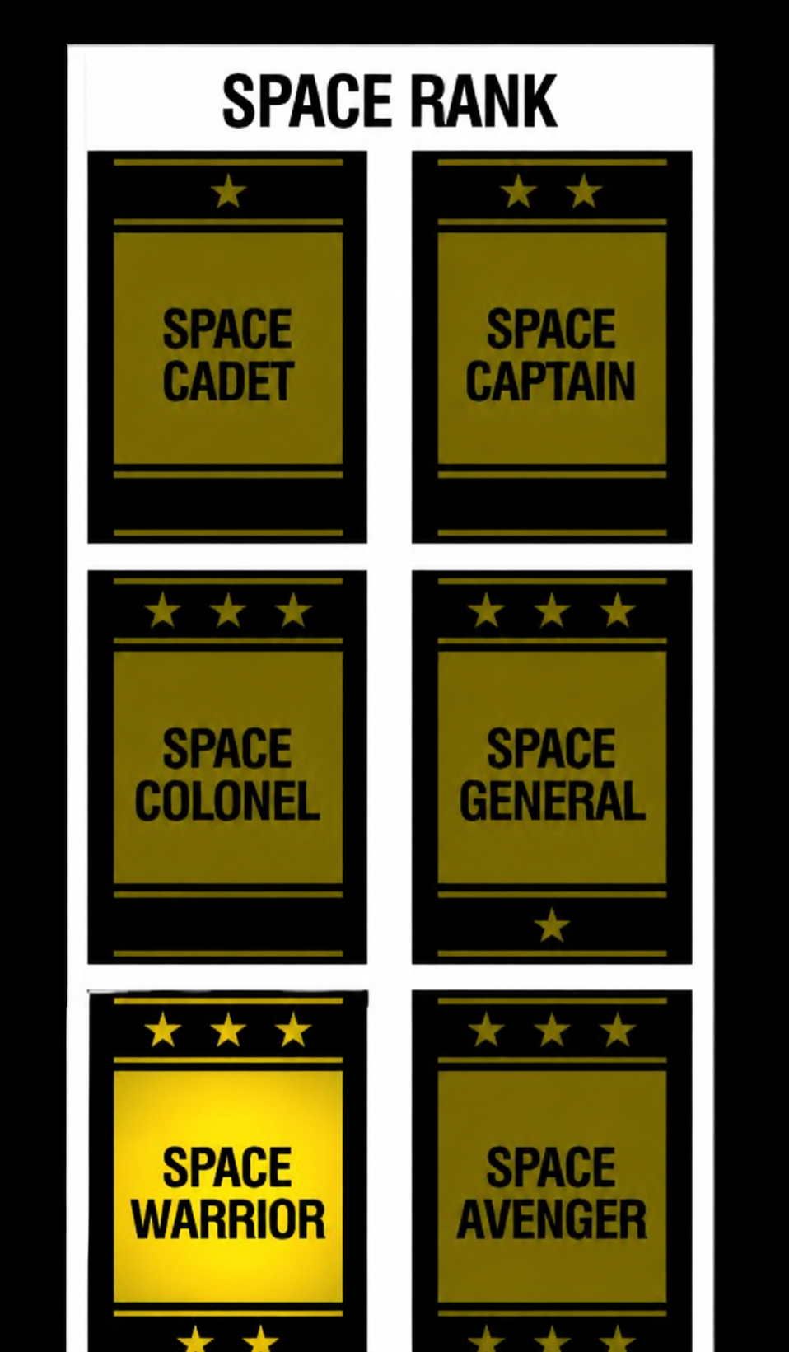
Space Warrior follows TERSE beyond control flow. The mature system coordinates the sensory identity of a game: shapes and text on the screen, scheduled animation, synthesized effects, and—in Gorf—Votrax speech. Native engines expose these subsystems as compatible vocabularies.

Graphics as compiled vocabulary
Astrocade graphics reward native code. Screen addresses are packed, pixels are two bits wide, and the Function Generator can shift, rotate, expand, combine, and report collision state while writing video memory. TERSE keeps those operations native and gives higher-level words stack interfaces for position, color, pattern, text, and shape.
The VGS documents name this approach directly. Words such as VECTOR, POST, CPOST, DRAW, BOX, ELLIPSE, SHAPE, COLOR, and SCROLL present graphics as a vocabulary. A compiled game definition can arrange those words without repeating the address arithmetic and Function Generator setup inside every mission or task.
The surviving Ms. Gorf disks show the corresponding asset pipeline. Source screens define patterns with forms such as PATTERN, QUADPAT, and byte emitters; animation screens build tables that refer to those patterns; and the cross-compiler writes three independently allocated regions in XC.PATTERNS:
Target region | Confirmed start | Product
Pattern index | $4000 | Stable game-facing pattern numbers and addresses
Animation tables | $4200 | Animation records referring to pattern indices
Pattern data | $8000 or $8040 | Function Generator bitmap bytes
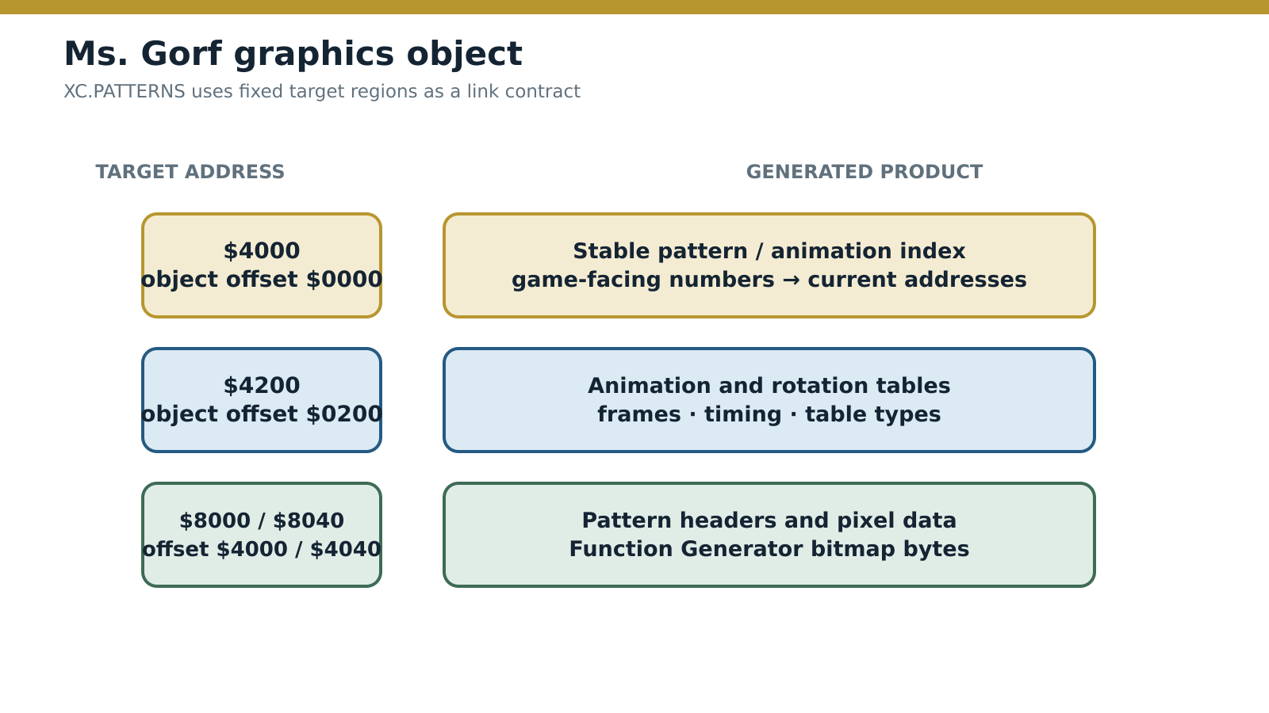
Figure — Ms. Gorf’s generated graphics regions form a stable link contract.
Source: Reconstructed from the Ms. Gorf cross-compiler and loader blocks.
Two surviving build snapshots use the two pattern-data origins. BINLOAD copies 16 KB into $4000-$7FFF in a host/target memory image, while LLOAD transfers 18 KB covering $0000-$47FF to the ICE target through a staged handshake. The ICEBOX receiver at $C000 acknowledges each 1 KB block, maps the external target, and starts the image at zero. These paths establish development loading and hardware testing. The MSGORF allocation table reconstructs the large GORF4A pattern as a 13 KB TERSE file, while MSGORPAT and MSGPATLD contain player, enemy, explosion, shield, mine, and animation definitions.
This expands the TERSE model: the language system compiled executable threads and generated the structured data those threads consumed.

Animation and VGER tasks
An animation is more than a list of bitmaps. It needs a current frame, timing, position, transition rules, and ownership by a live game object. VGER supplies that scheduled layer. Tasks wait on timers, yield, select patterns, alter vectors, and transition to other behaviors while interrupt-driven native code keeps the machine moving.
Robby Roto’s FLSHT example already shows the essential rhythm: perform an action, arm a timer, wait, and loop. Larger game tasks add vector records, collision services, destinations, animation maps, and task-to-task transitions. The threaded form is effective here because animation logic contains many small decisions surrounding a few expensive native operations.

Sound as event submission
The Astrocade sound hardware is register-oriented and timing-sensitive. Gorf submits sound material through TERSE-callable words. Interrupt-driven native players advance the active streams while game logic invokes named events. The sound machinery owns continuation, completion, and concurrent processor state.
That division matches the graphics design:
Compiled TERSE decides | Native subsystem performs
Which game event occurred | Register writes and timing
Which sound or musical stream to start | Per-frame stream advancement
Whether several effects form one event | Processor allocation and completion
When gameplay may continue | Hardware-facing update work
TERSE gives the rest of the game a compact, named interface to an asynchronous native sound engine.

Speech as a queued service
Gorf adds the Votrax SC-01 speech synthesizer. The device accepts phoneme codes and exposes readiness timing; natural phrases require ordered phoneme streams, pauses, and coordination with game events. TERSE words and game-specific tables submit phrases to a queued native speech service rather than blocking mission logic for every phoneme.
Speech therefore demonstrates the same boundary at its clearest:
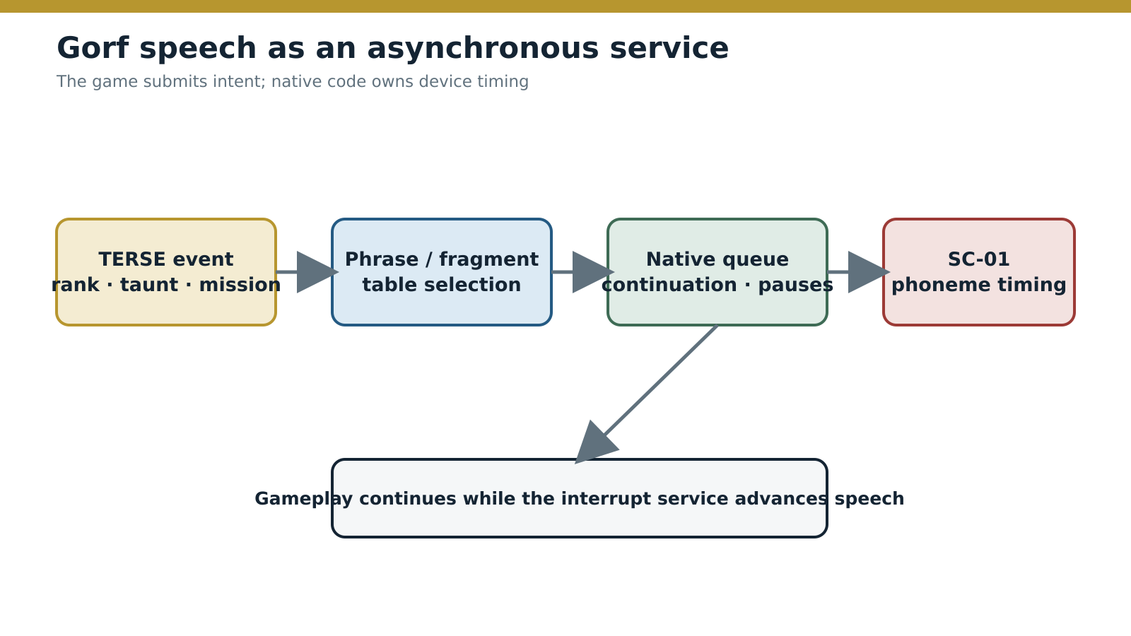
Figure — Gorf submits speech intent to an asynchronous native service.
Source: Derived from the Gorf ROM and Votrax interface.
The game-level word expresses intent—announce a rank, taunt the player, report a mission state. Native code handles device readiness and phoneme delivery. Graphics, sound, and speech differ electrically, but TERSE makes all three available through the same compositional model.

Space Avenger — Evolution, reuse, and specialization
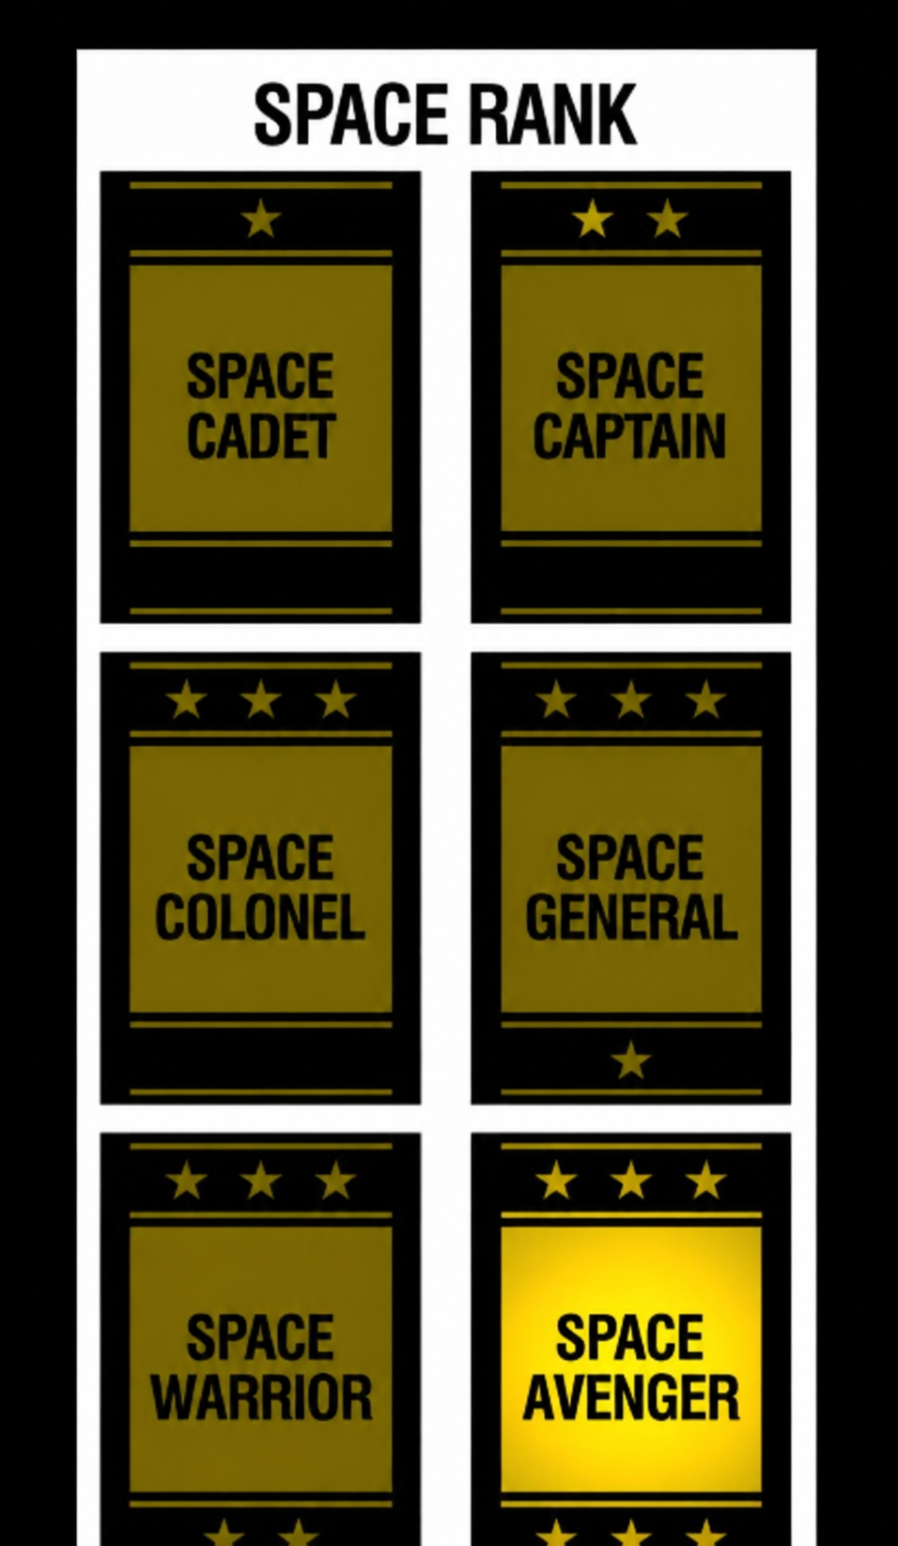
Space Avenger returns to the historical line with the full architecture in view. Robby Roto reveals how developers wrote a large TERSE/VGER game. Demons & Dragons then carries the mature runtime onto a banked 16-color board, and Professor Pac-Man develops that same platform into a much larger data-heavy product whose genre bears little resemblance to Gorf.

Robby Roto: TERSE source in the open
The Adventures of Robby Roto! provides evidence unavailable for the other games. Its ROM contains the mature Gorf-family runtime, while surviving development blocks contain a substantial body of original TERSE application source. The Bitsavers ROTO extraction contains 202 screens in 39 working files: 196 reproduce the established source corpus exactly after screen-format normalization, one restores the omitted text of global block 306, four are blank, and one (OT:2) is damaged. No revised screen appears in this working set. The larger archive remains incomplete, but it exposes colon definitions, CODE and SUBR routines, variables, arrays, data tables, conditional compilation, task bodies, loader screens, and build variants.
The blocks show TERSE as the language in which the project was organized. Groups of blocks cover player and monster behavior, maze generation, pathfinding, rendering, scoring, vector mathematics, animation, collision, game control, and diagnostics. The project structure is a growing vocabulary.

Original source to threaded ROM: FLSHT
The floppy locates global block 186 at MA:1, retaining this definition verbatim:
: FLSHT ;TASK:
BEGIN DIVG FLSHR 30 TIMER!-ON WAIT 0 END ;
The released ROM contains its compiled definition at $AB23-$AB38. These 22 bytes come directly from rotox7.bin:
AB23 CF 15 16 9F 19 FC AA C5 00 1E 04 1B 49 19 DD 00
AB33 CD 03 26 AB B0 00
Decoded with the resident Robby Roto vocabulary, the bytes are:
FLSHT: ; original source: : FLSHT
db $CF ; colon entry: RST $08
dw $1615 ; ;TASK:
FLSHT_LOOP: ; BEGIN
dw $199F ; DIVG
dw $AAFC ; FLSHR
dw $00C5 ; byte-literal word
db $1E ; decimal 30
dw $1B04 ; TIMER!-ON
dw $1949 ; WAIT
dw $00DD ; constant zero
dw $03CD ; END: repeat while flag is zero
dw FLSHT_LOOP ; $AB26
dw $00B0 ; ; return from colon definition
This is the compiler boundary made visible. BEGIN emits no target cell; it records $AB26 for the later loop operand. Decimal 30 becomes the compact byte-literal form $00C5,$1E. END becomes a runtime token followed by the inline address $AB26. The source semicolon becomes the return token $00B0.
FLSHT is declared as a VGER task, performs the flash action, arms a timer, waits, pushes zero, and repeats through END. The compiler has reduced one readable source line to a compact threaded body while retaining calls to native and compiled services through the same token format.
File E, local screen 2 (global block 231), records its installation site:
( LINK TO FLASHER ) ' FLSHT 3FF6 U!
Tick (') supplies the target execution address and U! installs it at the specified target location. Definition, compiled body, and source-level use are therefore all visible in the surviving project evidence.
Larger task definitions use the same form. The player task R:B, for example, sets source and animation state, enters a BEGIN loop, yields through DIVG, examines player state with CASE, configures motion and destination services, and attaches native or compiled behavior words. Gameplay reads as a vocabulary of operations rather than a sequence of raw jumps.

Original source to native ROM: MTC?
The floppy locates global block 260 at LFN:1. It shows exactly how a performance-sensitive operation enters the vocabulary. MTC? tests a row and column against a nearby-object list:
( column row list -- flag )
CODE MTC?
H POP, EXX, D POP, H POP, E H MOV, EXX,
X PUSHX, NEARBYLIST CALL,
0 H LXI, 0=, IF, H INX, THEN,
X POPX, H PUSH, NEXT
The compiler’s postfix Z80 assembler emitted 22 bytes at $933E-$9353 in rotox6.bin:
933E E1 D9 D1 E1 63 D9 DD E5 CD 1F 93 21 00 00 20 01
934E 23 DD E1 E5 FD E9
Conventional Z80 disassembly decodes the direct result:
MTC_question:
pop hl
exx
pop de
pop hl
ld h,e
exx
push ix
call $931F ; NEARBYLIST
ld hl,$0000
jr nz,$934F
inc hl
pop ix
push hl
jp (iy) ; NEXT
Here the correspondence is instruction-for-instruction. H POP, emits E1; EXX, emits D9; NEARBYLIST CALL, emits CD 1F 93; and NEXT emits FD E9, the native return to threaded dispatch. The body consumes three TERSE stack cells, calls a native helper, normalizes the result to zero or one, pushes the flag, restores IX, and resumes the dispatcher. Compiled callers see only the stack effect. There is no interpreter-to-native bridge.
The two Robby Roto examples prove both halves of the cross-compiler. FLSHT shows source becoming threaded cells and inline operands. MTC? shows the same source system assembling native Z80 into the target dictionary.

A documentary omission closed by the disk
File R, local screen 9, restores global block 306, whose heading was present in the source index but whose body was absent from the prose source document:
( CHAMBER REVEALER TASK )
: C:RT ;TASK: DIVG PLYRV GRCD ' CH:R SETCO COGO ;
DECIMAL -->
The ROM disassembly already contains the compiled C:RT definition as block 306. The floppy closes a documentary extraction gap; it does not establish a different game revision.

Source-level product engineering
The surviving blocks record build behavior as well as game logic. Conditional forms choose processor or product variants. Wrapper words hide the selected protected-memory implementation:
: WPB! B! ; : WP! ! ;
: 1+WPB! 1+B! ; : 1-WPB! 1-B! ;
: WPZERO ZERO ; : WPBONE BONE ;
: WPBZERO BZERO ;
Callers use stable write-protected vocabulary while the selected build supplies the appropriate underlying behavior. Professor Pac-Man later applies the same architectural idea through native address-aware stores and bank-local linkage entries.
Robby Roto therefore fills a crucial historical gap. Gorf proves the mature runtime in a shipped multi-system game; Robby Roto shows developers using that generation of TERSE and VGER as a source-level production environment.

Demons & Dragons: the banked 16-color bridge
Demons & Dragons is a 1982 unreleased DNA prototype and a main-line TERSE product. Its fixed ROM initializes the mature register ABI—BC as the threaded instruction pointer, SP as the parameter stack, IX as the control stack, and IY as the dispatcher—and enters the same seven-instruction direct-threaded loop used by Gorf, Robby Roto, and Professor Pac-Man. Native words return through JP (IY) throughout the fixed and banked ROMs.
The foundational vocabulary begins immediately after the dispatcher. Its ordering and machine-code bodies match Gorf and Professor Pac-Man across long byte-exact runs. Stack operations, literals, arithmetic, memory words, branch and loop control are the same implementation family. Demons & Dragons was written in TERSE.
Its larger contribution is the hardware transition. The program combines fixed ROM at $0000-$3FFF and $C000-$DFFF with switchable windows at $4000-$BFFF. Those windows carry game logic, tables, strings, and graphics for the 16-color board. MAME’s Professor Pac-Man map directly extends the Demons & Dragons map, and the Professor Pac-Man bank-switch handler begins with the Demons & Dragons operation before adding its own selection rules.
The application spans the fixed image and all three bank contexts. The current structural decode identifies 182 colon definitions containing 5,553 threaded cells: 70 definitions in fixed X1, X2, and X9; 66 in bank 1; 29 in bank 2; and 17 in bank 3. X10–X16 combine generated graphics and tables with bank-local TERSE definitions.
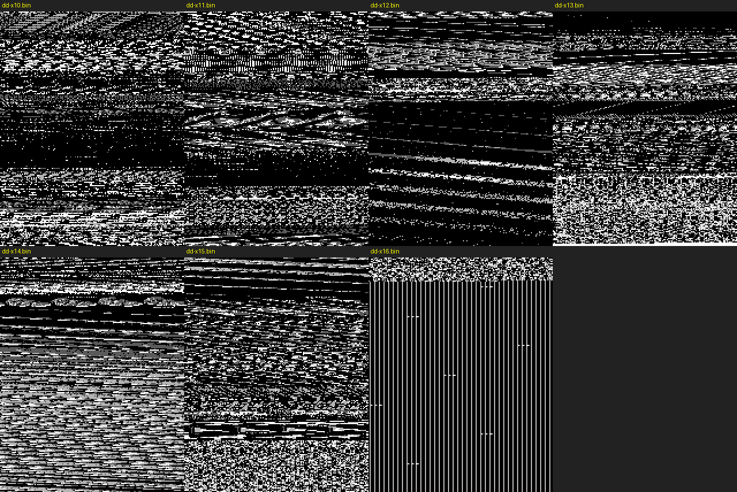
Figure — Decoded Demons & Dragons graphics pages from the banked ROM set.
Source: Rendered from the byte-exact prototype ROMs. Fixed startup code selects a bank, reads its exported entry vectors, and executes the selected module through the TERSE EXECUTE path.
Two Demons & Dragons ROMs contain development-system material.
The final part of dd-x7.bin contains a linked fragment of the host Forth dictionary, including LOAD, LINELOAD, INIT-DIR, BLOCK, FILE-SIZE, DESTROY, and RENAME. Its link fields and threaded bodies use host addresses rather than target-game addresses. This is development-host material carried into the programmed X7 image.
dd-x16.bin divides exactly into eight 1 KB Forth blocks. Block 0 contains target bytes. Blocks 1–7 retain the empty-screen initializer --> followed by spaces. X16 is an 8 KB block file used as a ROM image: the required target block was written and the seven unused source screens remained intact.
X7 and X16 document the block-oriented host workflow at the ROM-production boundary and connect the Forth development environment directly to a programmed TERSE image.
Demons & Dragons closes the architectural gap between the mature 1981 games and Professor Pac-Man. DNA moved TERSE onto the banked 16-color board, retained the established vocabulary and ABI, and created the software base that Professor Pac-Man later expanded.

Professor Pac-Man: selective reuse and specialization
Professor Pac-Man appeared five years after Sea Wolf II and two years after Gorf. It extends the Demons & Dragons banked platform into a substantially larger product: nine 8 KB program ROMs are joined by fourteen populated 16 KB question EPROMs, with hardware bank selection controlling the visible program and data windows.
The fixed program ROM nevertheless begins with the same TERSE-family design:
- RST $08 colon entry;
- BC threaded instruction pointer;
- SP parameter stack;
- IX return and loop stack;
- IY dispatcher continuation;
- direct 16-bit execution tokens;
- native return through JP (IY);
- Gorf-family primitive ordering and detailed implementation matches.
The decoded resident field contains 100 dispatchable words. It retains shared Gorf words where useful, omits unused vocabulary, promotes some former colon definitions to native code, and adds stack-frame and protected-memory services. Control-flow analysis identifies 357 physical colon definitions containing 4,925 validated threaded cells across the nine program ROMs.
Those figures establish Professor Pac-Man as a large TERSE application with a substantial native support layer.

Teaching example: bank switching as a word
The normal program configuration is selected by a short colon definition:
SELECT_SUPER_GAME_CONFIGURATION_1:
rst $08
dw _LITbyte
db BANK_CONFIG_1
dw _LIT
dw PORT_BANK_SELECT
dw _OUTP
dw _RETURN
In source-like form, its meaning is simply:
: SELECT-SUPER-GAME-CONFIGURATION-1
BANK_CONFIG_1 PORT_BANK_SELECT OUTP ;
Here the hardware boundary is explicit. OUTP is a general TERSE I/O word; the selector value and port identify Professor Pac-Man’s bank hardware. The definition maps the normal program pair into the lower window and the second program pair into the upper window.
Question selection builds on the same operation. The decoded word that chooses a random populated question bank performs this sequence:
- read the configured random-bank bound;
- generate an index and add the question-bank selector base;
- save the selected value as current state;
- write that selector to port $F3 through OUTP;
- read the selected bank’s root pointer at $4000;
- reject the bank and repeat if the directory word is $FFFF.
The higher-level selector then rejects questions found in a sixteen-entry recent history. The question-round controller temporarily selects the required program configuration, chooses and presents a question, and restores the normal configuration before returning.
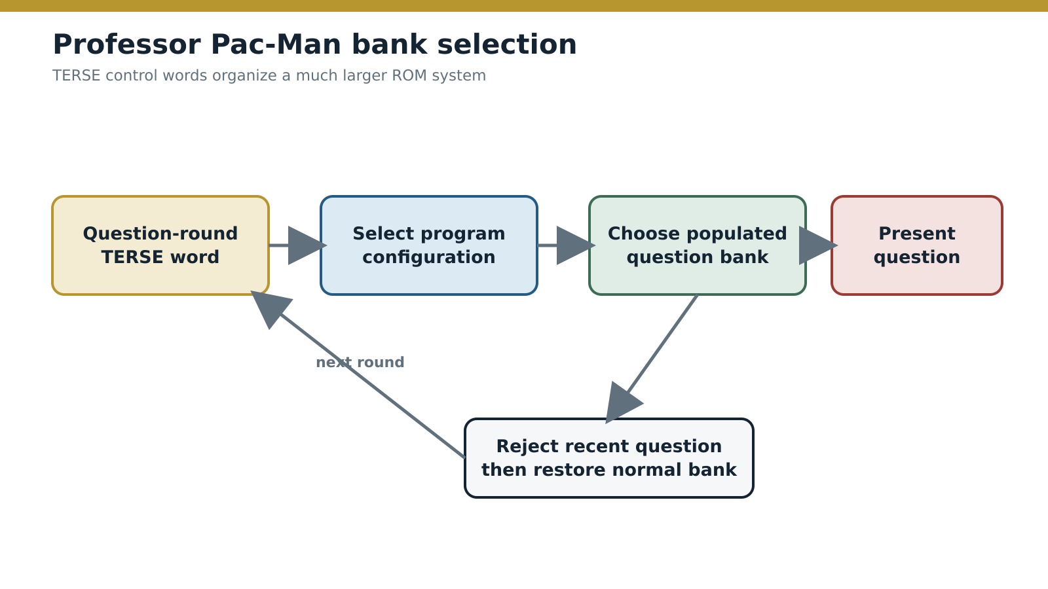
Figure — Professor Pac-Man specializes TERSE control for a banked question system.
Source: Derived from the Professor Pac-Man ROM disassembly and memory map.
This is TERSE doing what it did in Sea Wolf II—expressing control above native and hardware-specific operations—but at a much larger scale. The language did not need a new execution model to accommodate banking. It needed new constants, application words, and data-aware control definitions.

Selective linking and native promotion
Professor Pac-Man does not contain a mechanical copy of Gorf’s dictionary. It omits unused words such as DLIT, several return-stack transfers, some unsigned comparisons, and outer-loop index helpers. It provides native implementations for operations that were compiled in Gorf, including MAX, MOD, and /, and adds bounded CASES dispatch plus specialized parameter/local frame accessors.
That pattern is stronger evidence of source lineage than byte-for-byte copying would be. The execution ABI and vocabulary organization remain recognizable, while application-specific linking and optimization change the resident image.

Protected memory without caller duplication
The game’s ordinary store vocabulary incorporates the board’s protected-memory rules. B!, !, byte/word zero and one, increment, decrement, add, subtract, and block movement route through native helpers. A protected target triggers the hardware unlock sequence; ordinary RAM uses a direct write.
Compiled callers invoke the same store word regardless of the target address. Banked code also uses linkage entries that jump to the canonical fixed-ROM implementations. Hardware policy is localized at the vocabulary boundary instead of being copied into every question, diagnostic, or presentation thread.

Stable contract, evolving vocabulary
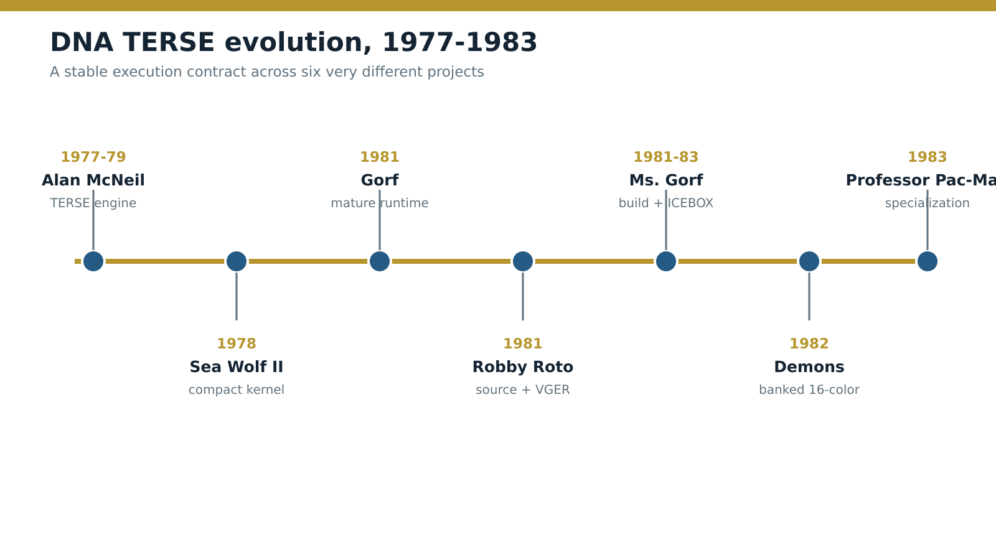
Figure — DNA TERSE evolution from Alan McNeil’s engine through Professor Pac-Man.
Source: Dates and roles established by the primary source base listed in this paper.
Project | TERSE’s role in the evolution | Primary evidence
Sea Wolf II (1978, released) | Compact linked kernel for foreground sequencing | Complete byte-exact ROM disassembly
Gorf (1981, released) | Mature reusable dictionary and broad game-service vocabulary | Complete byte-exact ROM disassembly and runtime traces
Robby Roto (1981, released) | Full source-level TERSE/VGER production language | ROM plus original development blocks and exact compiler-output matches
Ms. Gorf (1981–1983, unreleased prototype) | Host cross-compiler, separate target objects, graphics build, and ICEBOX test loop | Development disks, loaders, generated object data, ICEBOX software, firmware, manuals, and hardware
Demons & Dragons (1982, unreleased prototype) | Mature runtime transferred to banked 16-color hardware | Complete ROM set, dispatcher and ABI, vocabulary matches, bank map, and embedded host/block-file evidence
Professor Pac-Man (1983, released) | Selective reuse and expansion on the Demons & Dragons platform | Nine byte-exact program-ROM sources and bank-aware thread map
The numeric counts describe different evidence sets. Sea Wolf II’s 11 counts kernel words; Gorf’s 82 counts a foundational native field; Robby Roto’s source analysis counts named source forms; Demons & Dragons’ 182 counts structurally decoded colon definitions; Professor Pac-Man’s 357 counts physically distinct decoded colon bodies.

The implementation fingerprint
The shared lineage rests on a combination of features:
- BC, SP, IX, and IY retain the same execution roles.
- The dispatcher reads a little-endian native address and jumps through HL.
- Colon entry saves the caller’s BC on the IX control stack.
- The return word restores BC from IX.
- Native words resume with JP (IY).
- Literals, branches, strings, and array bases are inline BC operands.
- Gorf, Robby Roto, Demons & Dragons, and Professor Pac-Man share vocabulary order and detailed instruction sequences across the foundational dictionary.
- The mature games retain custom compact forms such as LITbyte.
- Robby Roto source names compiler forms that correspond directly to the ROM structures.
- Ms. Gorf documents the cross-compiler and object workflow that produced target code and graphics.
- The ICEBOX archive contains the CP/M assembly environment, target-bus bridge, hardware monitor, and PROM-programming stage.
- Demons & Dragons establishes the banked 16-color transition, and Professor Pac-Man extends its map, bank control, ABI, and stable linkage words.
Register allocation, custom optimizations, word order, matching primitive bodies, source forms, and build artifacts together establish the TERSE source and implementation lineage.

Evolution rather than a fixed binary
The differences are equally important:
- Sea Wolf II contains a narrow early control vocabulary and descriptive words that cannot all be assigned later standard names.
- Gorf links general stack, loop, arithmetic, hardware, and service operations unnecessary in the smaller game.
- Robby Roto builds extensive VGER tasks and game-specific native coordinate, maze, and object services.
- Ms. Gorf separates logic, animation tables, and pattern data into managed cross-compiler products and loads the result through the ICEBOX receiver; the ICE archive supplies the machine, firmware, development disk, and PROM utility behind that step.
- Demons & Dragons applies the mature runtime to banked 16-color hardware and contains a host dictionary fragment and Forth block-file structure in its prototype ROM images.
- Professor Pac-Man removes unused words, promotes selected operations to native code, and adds frames, protected-memory stores, and bank-aware services.
TERSE was a maintained software system with a stable execution contract and selectable vocabularies tailored to each game.

Technical evaluation
Design choice | Engineering value | Cost
Two-byte native execution tokens | Compact calls and reusable control definitions | Every word requires token fetch and indirect transfer
Uniform native-word ABI | Expensive operations remain optimized Z80 | Native and interrupt code must leave TERSE state intact
Separate parameter and IX control stacks | Game values remain distinct from returns and loops | SP is also the Z80 call stack, so every native stack effect must balance
Inline literals and branch targets | Dense code without a separate literal pool | Static decoding requires word-specific operand knowledge
Selectable linked vocabularies | Each game carries only the system it uses | Word addresses and resident subsets are not universal
Thin hardware abstraction | Repeated board sequences become named operations without hiding performance | Application vocabulary remains hardware-aware
TERSE fits the Astrocade arcade platform unusually well. The Z80 provides index registers for an independent control stack, indirect jumps for direct-threaded dispatch, and enough register state to keep the execution context resident. The Astrocade hardware rewards short native routines for blitting, collision, sound, and I/O. TERSE lets those routines remain native while removing repeated higher-level sequencing.
Its lasting feature is the contract around the seven-instruction dispatcher:
- how parameters are represented;
- where threaded and native returns live;
- how inline operands advance BC;
- how a native word returns to dispatch;
- how game services become vocabulary.
That contract provides a practical middle ground. TERSE avoids the principal cost of a pure interpreter because expensive work remains Z80. It avoids the maintenance cost of an all-assembly program because higher-level control paths can be named, factored, compiled, inspected, and reused.

Conclusions
The ROMs, source blocks, and development disks establish a coherent technical history.
Alan McNeil created the architecture that made this history possible. His 1977–1979 work at DNA established TERSE’s direct-threaded Z80 engine, stack and register contract, native-word interface, and selectively linked target vocabulary. Sea Wolf II placed that system in a commercial arcade game. The later teams expanded McNeil’s design into the mature dictionaries, development tools, graphics systems, task services, banked modules, and specialized products traced throughout this paper.
The surviving tools and source blocks also establish the production path. TERSE joined a host Forth development system to target images containing selected threaded definitions, native Z80 routines, and data objects.
Sea Wolf II proves the design at minimum scale: a small linked kernel uses two-byte execution tokens to organize native game operations inside 8 KB.
Gorf shows the mature form: a broad foundational dictionary and layered service vocabulary support a multi-mission game with graphics, diagnostics, sound, and speech.
Robby Roto reveals the development practice behind that runtime. Original blocks show developers composing colon words, native CODE and SUBR routines, VGER tasks, data structures, and build variants in one source system. The exact FLSHT and MTC? matches show both compiler products in the released ROM: threaded cells and native Z80.
Ms. Gorf exposes the production architecture around the language. Its project disks show source and asset blocks becoming separate cross-compiled logic and graphics products, then being combined, loaded, and executed through the ICEBOX. Its directory structures and the GORF4A allocation also make the one-kilobyte block-file model concrete at the disk level.
The ICEBOX completes that production account. Its CP/M disk contains the assemblers, loader, platform libraries, monitor source, and utilities used at the workstation. Its hardware documentation explains the internal 2.5 MHz development context, the external target-bus context, memory mapping, write protection, and breakpoints. Its split firmware images and Tinkerbell program carry the process from live target debugging to a programmed 2 KB ROM.
Demons & Dragons establishes the next hardware generation. It moves the mature Gorf-family runtime and vocabulary onto the banked 16-color platform, creating the direct software and memory-map predecessor of Professor Pac-Man.
Professor Pac-Man proves longevity and selective reuse. The game retains the execution ABI, primitive lineage, dictionary organization, and Demons & Dragons banked platform while tailoring the linked runtime to protected memory, diagnostics, presentation logic, and a large question database.
The evolution runs from a compact game vocabulary, through a reusable language and production system, onto a new banked hardware generation, and finally into specialized products assembled from that platform. TERSE’s central achievement was making native Z80, compiled game control, generated assets, and hardware services parts of one practical software method.

Notes and source base
Primary technical sources used for this analysis:
- Sea Wolf II byte-exact Z80/TERSE disassembly and technical README;
- Gorf revision 2 byte-exact disassembly and TERSE architecture reference;
- Robby Roto byte-exact disassembly, surviving TERSE source blocks, and source index;
- the official non-commercial Robby Roto ROM release, used to verify the exact $AB23-$AB38 and $933E-$9353 byte sequences independently of the disassembled source;
- Ms. Gorf MSGORPAT, MSGPATLD, and MSGORF development-disk images, the exact 13 KB GORF4A source file, 64 byte-verified directory entries, cross-compile loaders, object-placement tools, and the 1 KB DPATCH integration helper;
- the Nutting ICEBOX archive: ICE.IMD, exact CP/M file extraction, Z80 monitor source and binaries, TDL and Digital Research development utilities, Astrocade libraries, 2 KB PROM-programmer source, ICE5 hardware manual, GAS Monitor v2.33 manual, I/O documentation, schematics, board scans, and machine photographs;
- Demons & Dragons dd-x1 through dd-x16 program ROM set, byte-level TERSE kernel and vocabulary analysis, Gorf/Professor Pac-Man code comparison, and MAME banked-memory implementation;
- Professor Pac-Man pps1–pps9 byte-exact sources, threaded-code map, TERSE vocabulary, and hardware/banking analysis;
- TERSE Standard Glossary, September 21, 1981;
- Terse Verbs source screens;
- Video Game System Glossary;
- Interactive Debugger;
- Edit Verbs, revision 4;
- Z-80 Assembler;
- ICE5 hardware and operation manual;
- GAS Monitor Commands, version 2.33, September 21, 1981;
- Jamie Fenton’s March 1979 Addin listing;
- Rickey Spiece discussion compiled by Richard C. Degler;
- Alan McNeil résumé material compiled by Adam Trionfo;
- TERSE naming and categorized-vocabulary references;
- MAME astrocde.cpp hardware definitions and ROM maps.
- MAME icebox.cpp machine model, implemented I/O map, boot-status notes, and command-line media behavior.
The ROM disassemblies remain the authority for executed behavior. Historical documents establish intent and terminology; surviving source establishes developer notation; neither substitutes for byte-level validation against a particular shipped game.

Alan McNeil résumé excerpt reproduced in Adam Trionfo, Programmers of the Bally Arcade/Astrocade Built-in Programs (2016). McNeil lists his Dave Nutting Associates employment as March 1977–April 1979 and names both Sea Wolf II and “TERSE, A Z80 direct threaded code version of FORTH” among his projects.
Tony Miller and Rickey Spiece statements compiled in Trionfo, Programmers of the Bally Arcade/Astrocade Built-in Programs, and Richard C. Degler’s Discussion with Rickey Spiece. Both credit McNeil; they recall different expansions of the acronym.
Alan McNeil résumé excerpt reproduced in Adam Trionfo, Programmers of the Bally Arcade/Astrocade Built-in Programs (2016). McNeil lists his Dave Nutting Associates employment as March 1977–April 1979 and names both Sea Wolf II and “TERSE, A Z80 direct threaded code version of FORTH” among his projects.
Jamie (Jay) Fenton, Addin listing, March 1979. The assembly headers and command stream identify TERSE macros and graphics words including CIRCLE, SHOW, and BOX.
MAME project, src/mame/skeleton/icebox.cpp, current skeleton driver and archival engineering notes, https://github.com/mamedev/mame/blob/master/src/mame/skeleton/icebox.cpp; MAME command-line documentation, https://docs.mamedev.org/commandline/commandline-all.html.
David E. Turner recounts Jamie Fenton’s confirmation that Gorf was programmed in TERSE in the archived discussion compiled as Discussion with Rickey Spiece. Frank Palazzolo separately reported recognizing the Forth-family interpreter while emulating Professor Pac-Man and later receiving Fenton’s confirmation that the coin-op runtime was TERSE.

